

**ONLINE SHOPPING SYSTEM**

**Software Requirement Specification**

**(Version 0.7 – 07/11/2022)**

Member:

Trần Trung Việt - HE153481

Nguyễn Trung Hiếu - HE160326

Trần Công Minh - HE161354

Lê Sỹ Thái - HE160614

Vũ Hoàng Anh - 163109

– Hanoi, November 2022 –

**Table of Contents**

I. Overview 4

1. Introduction 4

2. System Functions 5

3. Use-Case Diagram 9

II. Functional Requirements 12

2.1. Home page 12

2.2. Register 13

2.3. Register for seller 15

2.4. Login 16

2.5. Forgot Password 18

2.6. View User Profile 19

2.7. Change Password 19

2.8. Show Products (For user) 20

2.9. View Product Detail (For user) 21

2.10. Add Address 22

2.11. Edit Address 24

2.12. Delete Address 25

2.13. Update Profile 26

2.14. Add to Cart 28

2.15. View cart 29

2.16. Delete Product in Cart 30

2.17. CheckOut 31

2.18. Place Order 32

2.19. View order 33

2.20. View Order Detail 34

2.21. Add Wishlist 35

2.22. My Wishlist 36

2.23. Delete product in "My Wishlist" 37

2.24. Add Feedback 38

2.25. View Feedback (For user) 38

2.26. Blogs List 39

2.27. Blogs Detail 40

2.28. Search Blogs (For User) 41

2.29. View Service 42

2.30. Search Service 44

2.31. Search Products 46

2.32. Admin Dashboard 47

2.33. List of Account (Admin) 48

2.34. Account Information (Admin) 49

2.35. Search Account (Admin) 51

2.36. List of Shops (Admin) 52

2.37. Shop Information (Admin) 53

2.38. Search Shop (Admin) 54

2.39. Report from User (Admin) 55

2.40. Search Report (Admin) 56

2.41. Seller Dashboard (Seller) 57

2.42. Manager Order (Seller) 59

2.43. Manager Product (Seller) 61

2.44. Add new Product (Seller) 62

2.45. Edit Product 64

2.46. Delete product 66

2.47. Feedback List (Seller) 67

2.48. Reply Feedback 68

# I. Overview

## 1. Introduction

This project is aimed at developing an online shop system which supports for the online shopping & product online selling for the shop or any independent organization who want to sell online. This system support for the below types of user:

• Guest: unregistered users

• Customer: they are registered users who are actual customers or potential customers

• Seller: the sale members of the organization

• Admin: the organization leader/manager, acts as the system administrator

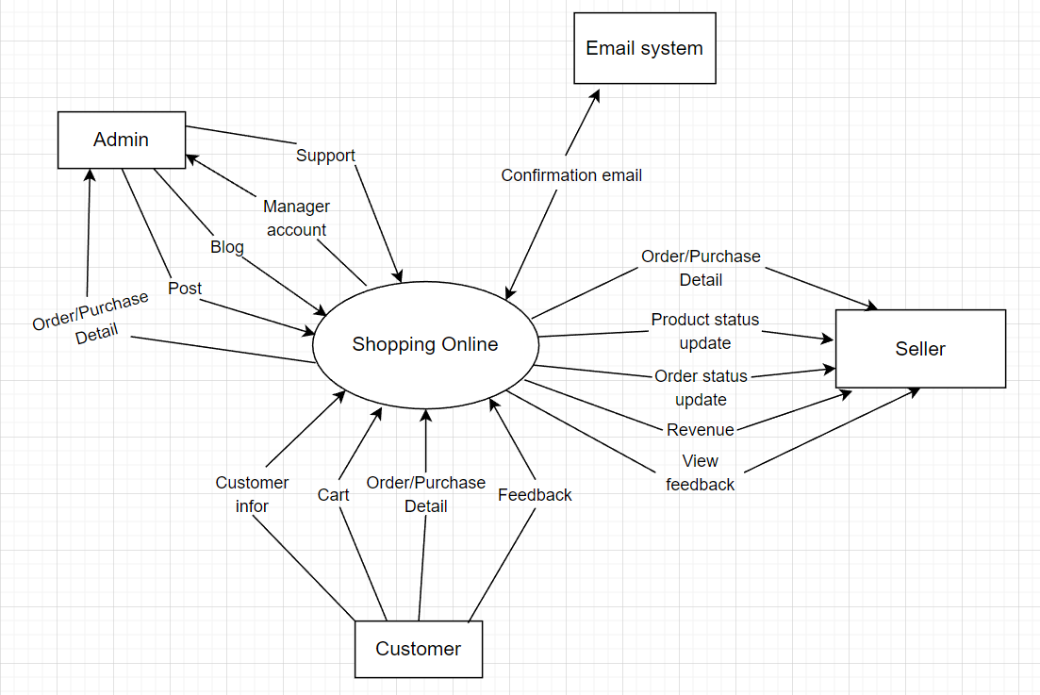

*Figure 1.1: Context Diagram For Online Shopping System*

## 2. System Functions

#### a. Screen Flow

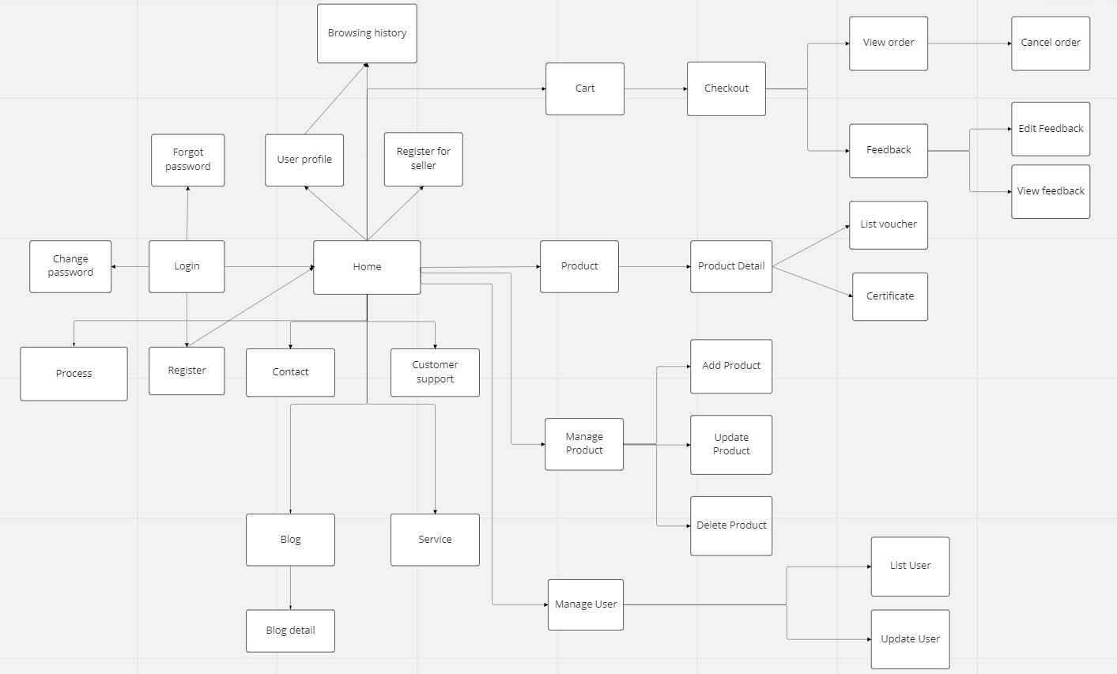

*Figure 1.2: Screen Flow For Online Shopping System*

#### b. Screen Details

|  |  |  |  |
| --- | --- | --- | --- |
| **#** | **Feature** | **Screen** | **Description** |
| 1 | Show category | Home page | User can see a list of product categories. |
| 2 | Show product | Home page | Users can see a list of the latest products, or on sale |
| 3 | Search (For user) | Home page | Allows users to search for categories, products, product types by name |
| 4 | Login | Login | Allow users to access the system |
| 5 | Register | Register | Allow users to register for a new account to access the system |
| 6 | Register for seller | Register | Allow registered users to become sellers |
| 7 | Update profile | User profile | Allow users to update personal information |
| 8 | Change password | User profile | Allow users to change their personal password |
| 9 | Add address | User profile | Allow users to add an address to receive goods |
| 10 | Reset password | Reset password | The user requests to get new password |
| 11 | Add to cart | Product detail | The user will add the product to be purchased to the cart |
| 12 | View cart | Cart | User can see all the products that have been added in the cart |
| 13 | View order | My order (Customer) | User can see all their created orders |
| **#** | **Feature** | **Screen** | **Description** |  |  | **Screen** | **Description** |
| 14 | Cancel order | My order (Customer) | Users can cancel orders that don't want to buy |
| 15 | View favorite products | My Wishlist  (Customer) | Users can view products that have been added to favorites |
| 16 | View detailed statistics | Admin dashboard | Allows administrators to view detailed statistics, revenue, transaction history, .. |
| 17 | View list of accounts | Account Management (Admin) | Admin can view all user information in the system, or disable the account. |
| 18 | Search (For admin) | Account Management (Admin) | Admin can search for account by name, role |
| 19 | View list of shops | Shop Management (Admin) | Admin can see the information of the store, store owner, total products posted for sale |
| 20 | Search shop | Shop Management (Admin) | Quickly search for a store by store name, or store owner's name |
| 21 | View report | Report From Users (Admin) | View a list of reports submitted by users to the system through the Report function |
| 22 | Search Report | Report From Users (Admin) | Allows administrators to quickly search for a person's report when too many reports are sent to the system |
| 23 | View detailed statistics | Seller dashboard | Allows seller to view post statistics, products, customers, revenue, feedback & new customer trends |
| 24 | Add product | Manage Products (Seller) | Seller can add new products to the shop's product list |
| 25 | Edit product | Manage Products (Seller) | Seller can change the information of the product |
| 26 | Delete product | Manage Products (Seller) | Seller can delete product when the shop no longer sell it |
| 27 | Update order status | Manage Orders (Seller) | Seller can update the status of orders (wait for confirmation, delivery, delivered, canceled) |
| 28 | Delete order | Manage Orders (Seller) | Seller can delete order when order is canceled |
| 29 | Add new Blog | Manage Blogs (Seller) | Sellers can post new Blog posts on the website |
| 30 | Edit blog | Manage Blogs (Seller) | Sellers can edit the content, images, titles of old Blog posts |
| 31 | Delete Blog | Manage Blogs (Seller) | Remove Blog post from list |
| 32 | View list Feedback | Manage Feedback (Seller) | Sellers can see a list of user reviews about their products |
| 33 | Reply Feedback | Manager Feedback (Seller) | Sellers can respond to user reviews about their products |
| 34 | Add Feedback | Add Feedback (Customer) | Submit a product feedback review after a successful purchase |
| 35 | Report Shop | Report Shop (Customer) | Users can report back to the Administrator about the stores if they encounter a case of a store selling banned products, obscene, ... |
| 36 | Chat with Seller | Chat With Seller (Customer) | Allow users to message directly with sellers |
| 37 | View list blog | Blog (Customer) | Show the posts pagination the post search box, post categories, five featured posts |
| 38 | View blog detail | Blog detail (Customer) | Show post details, post categories, five featured posts. The Blogs List page is shown when the user clicks on a post category |
| 39 | Comment on Blog posts | Comment Blogs (Customer) | Write a review on a Blog post on the page after viewing it |
| 40 | Search Blog | Blog (Customer) | So that users can quickly search Blogs posts |
| 41 | View Service | Service (Customer) | If users need support or guidance, they can go to the Service section to see |
| 42 | Search Service | Service (Customer) | Find quick help with keywords |
| 43 | View Products History | Products History (Customer) | So that users can know their own purchase and viewing history |

#### c. User Authorization

|  |  |  |  |  |
| --- | --- | --- | --- | --- |
| **Screen** | **Role1** | **Role2** | **Role3** | **Role4** |
| Home page | X | X | X | X |
| Register | X | X | X |  |
| Register for seller |  | X | X |  |
| Login |  | X | X | X |
| Forgot password |  | X | X |  |
| Use profile |  | X | X | X |
| Add addresses |  | X |  |  |
| Change password |  | X | X |  |
| Admin dashboard |  |  |  | X |
| Seller dashboard |  |  | X |  |
| List of account |  |  |  | X |
| Account information |  |  | X | X |
| Product list |  |  | X | X |
| Category list |  |  | X | X |
| Add product |  |  | X |  |
| Edit product |  |  | X |  |
| Add category |  |  | X |  |
| Edit category |  |  | X |  |
| Search | X | X | X | X |
| Product status update |  |  | X |  |
| Update order status |  |  | X |  |
| View product detail | X | X | X | X |
| View shopping cart |  | X | X | X |
| Check out |  | X | X | X |
| View order |  | X | X | X |
| Cancel order |  | X | X | X |
| Feedback |  | X |  |  |
| View feedback | X | X | X | X |
| Feedback detail | X | X | X | X |
| Check bill |  | X | X |  |
| Supporting |  |  | X | X |
| List vouchers | X | X |  |  |
| Blogs list | X |  | X | X |
| Blogs detail | X | X | X | X |
| Service Support | X | X | X | X |
| List Service | X | X | X | X |
| Contact | X | X | X | X |
| Certificate | X | X | X | X |
| Service | X | X | X |  |
| Report page |  | X |  |  |
| Browsing history |  | X |  |  |
| Delivery method |  | X |  |  |
| Chat |  | X | X | X |

In which:

* Role1: Guest
* Role2: Customer
* Role3: Seller
* Role4: Admin

#### d. Non-Screen Functions

|  |  |  |  |
| --- | --- | --- | --- |
| **#** | **Feature** | **System Function** | **Description** |
| 1 | Remember Me | Login | System store user’s login account and password in cookies for future re-login |
| 2 | … |  |  |

## 3. Use-Case Diagram

#### a. General Use-Case Diagram

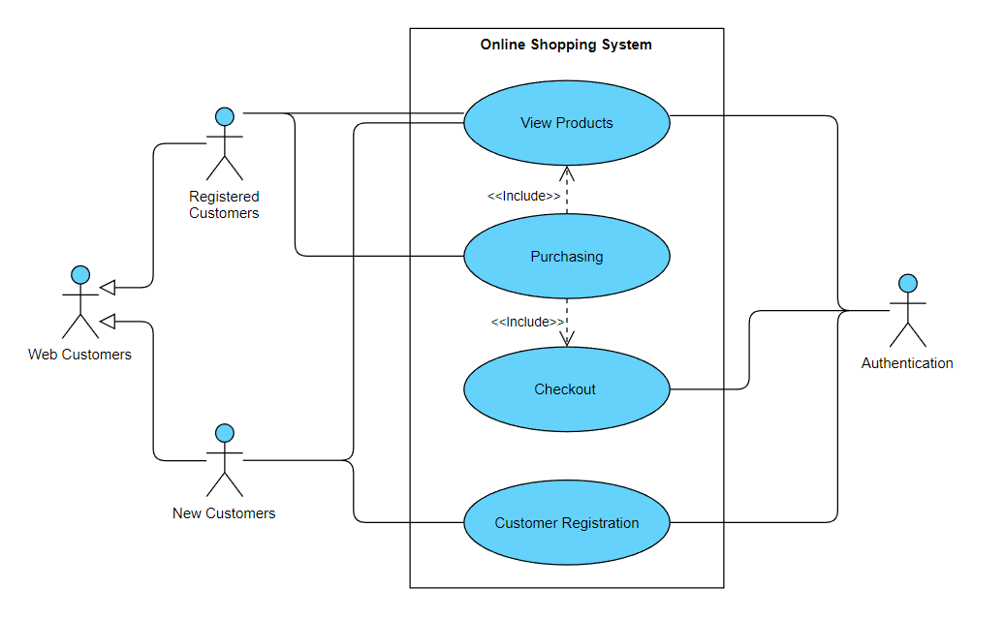

*Figure 3a Use-Case Diagram for Online Shopping System*

#### b. Admin’s Management System

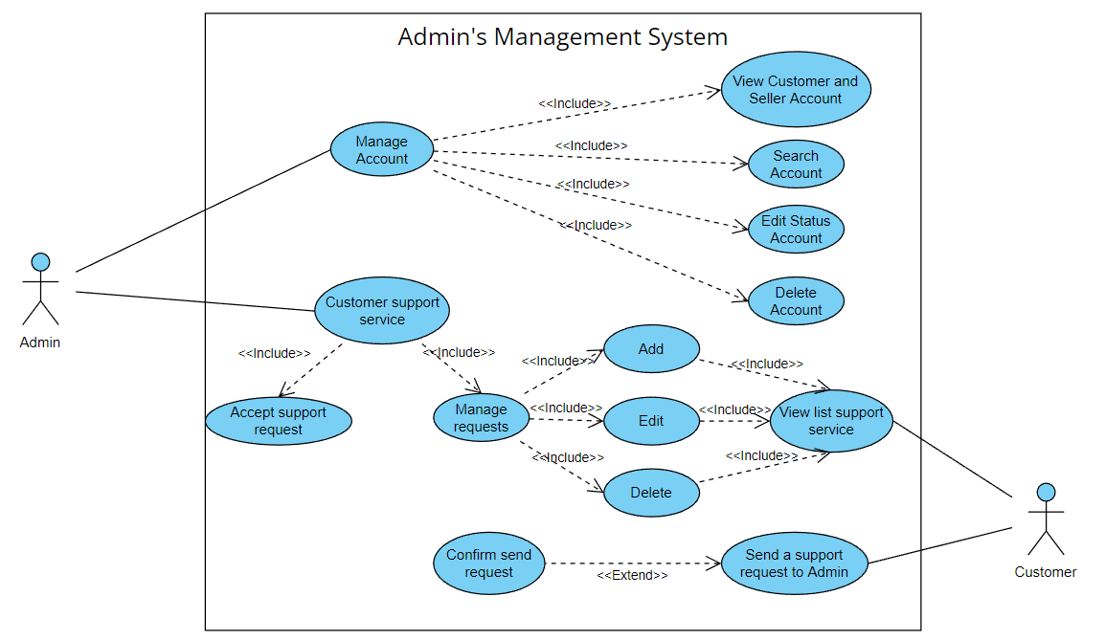

*Figure 3b Use-Case Diagram for Admin’s Management System*

#### c. Seller’s Management System

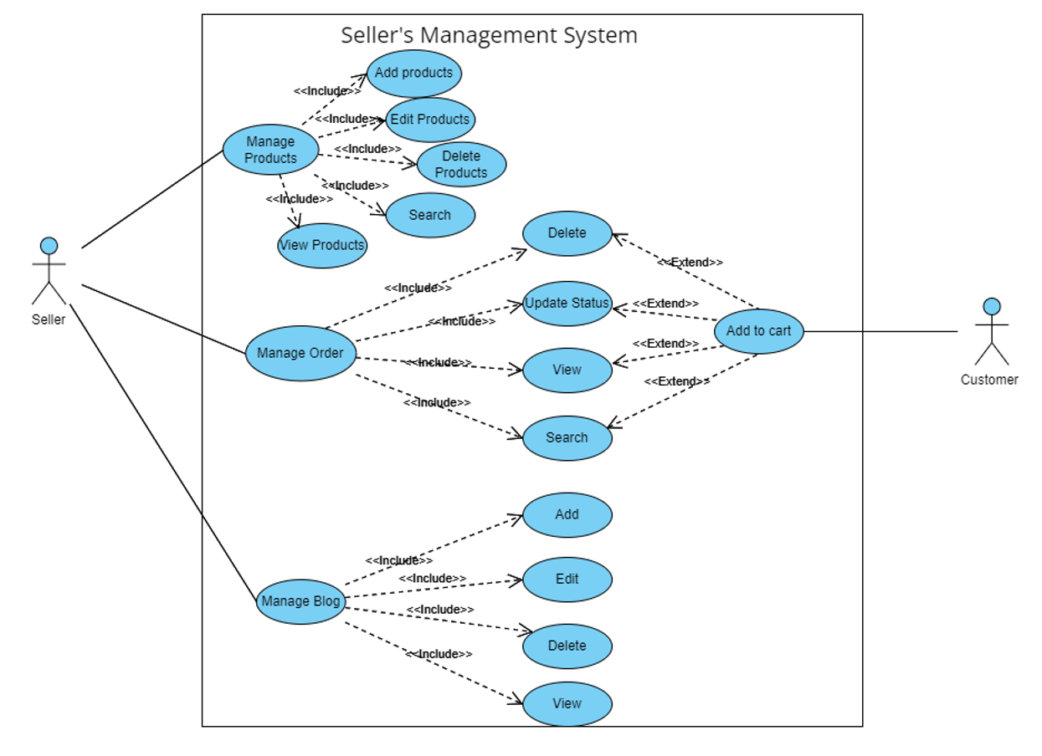

*Figure 3c Use-Case Diagram for Seller’s Management System*

#### d. Shopping Cart Use-Case Diagram

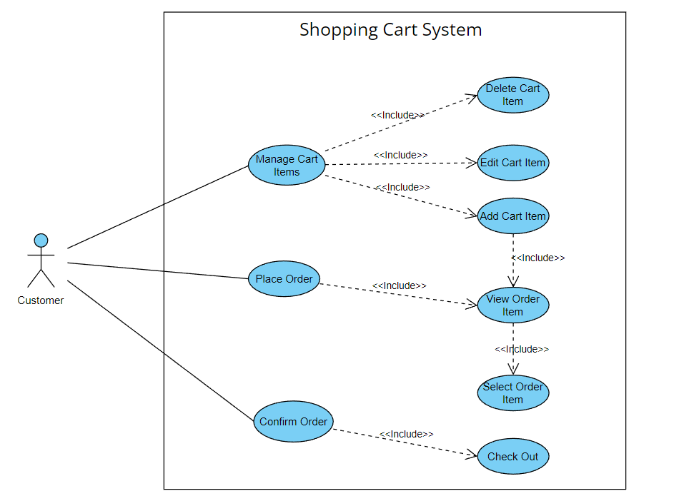

*Figure 3d Use-Case Diagram for Shopping Cart System*

# II. Functional Requirements

### 2.1. Home page

* Function trigger: The user visits the website's address then goes to the home page.
* Function description:
  + Actors/Roles: Guest, Customer
  + Purpose: Showcase feature product to customer
* Screen layout:

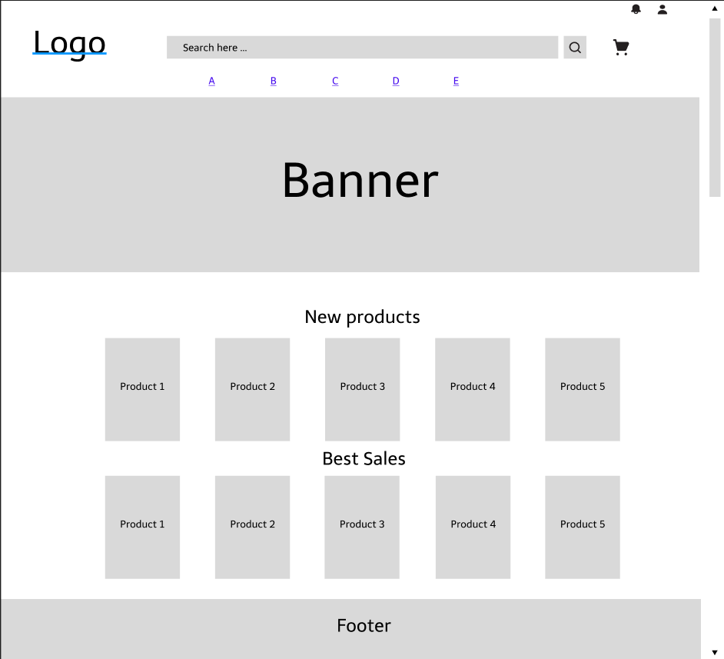

*Figure 2.1 Homepage screen*

* Function Details: Customers after accessing the website by following the link can view product information, categories, banners, latest products, discounts, brands, search for products, ...

### 2.2. Register

* Function trigger: After the user hovers over the person icon on the home page and chooses to register, the system will take the user to the Register page.
* Function description:
  + Actors/Roles: Guest
  + Purpose: Provide a form for customer to register an account.
  + Interface: There are pictures to welcome customers.
  + Data processing: Save email, username, password to data management system.
* Screen layout:

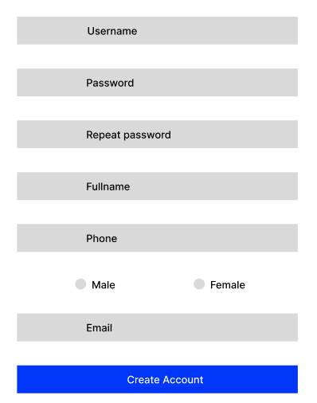

*Figure 2.2 Register screen*

* Function Details: Users register a new account by email, set a password for their account then click the Register button.
* Use-Case Description:

|  |  |
| --- | --- |
| Use Case ID | UC-01 |
| Use Case Name | Register |
| Actor | User |
| Description | This use case allows the user to register a new account which is used to access the system |
| Precondition | Do not have an account to log in to the system |
| Post-Condition | None |
| Main Flow | 1. User enters username, password and personal information  2. User submits username, password and personal information to the system  3. System to check the existence of Username  4. The system will check if the password entered in 'Confirm Password' is the same  5. System to check password format, phone number, email  6. Redirect to login page  7. End of use case |
| Alternative flows | 3a. Username exists  1. Error message username exists  2. The use case resumes at main flow step 1  4a. Password not same  1. Error message password is not the same  2. The use case resumes at main flow step 1  5a. Malformed  1. Show input request in correct format  2. The use case resumes at main flow step 1 |

### 2.3. Register for seller

* Function trigger: When the user clicks the button Become a seller, the system will go to the page Register to become a seller.
* Function description:
  + Actors/roles: Customer
  + Purpose: For users who want to become product sellers.
  + Data processing: Update account status from Customer to Seller.
* Screen layout:

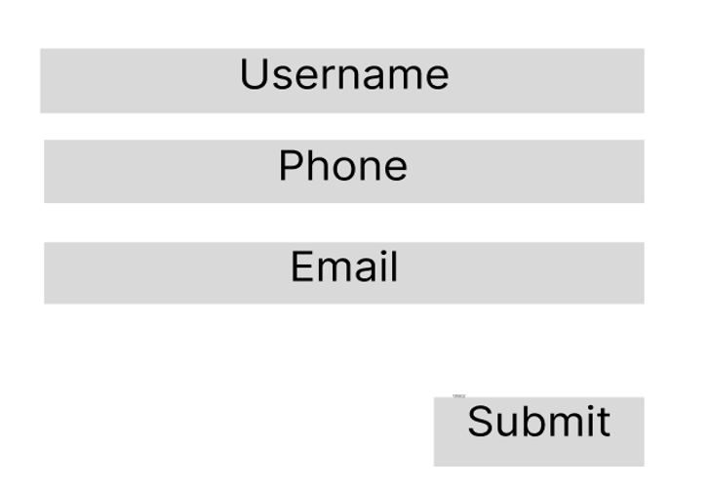

*Figure 2.3 Register For Seller Screen*

* Function Details: Register information to become a seller.
* Use-Case Description:

|  |  |
| --- | --- |
| Use Case ID | UC-02 |
| Use Case Name | Register for seller |
| Actor | User |
| Description | This use case allows users to sign up to become a seller |
| Precondition | Already have a valid account |
| Post-Condition | None |
| Main Flow |  |
| Alternative flows |  |

### 2.4. Login

* Function trigger: After the user hovers over the person icon on the home page and chooses to login, the system will take the user to the Login page.
* Function description:
  + Actors/Roles: Guest, Customer
  + Purpose: Allow users to login to the system to access more functions
  + Interface: There are header, wallpapers, website logos
  + Data processing: Check if the user has entered the wrong username or password, if wrong will display a message asking to re-enter. If entered correctly redirect the user to the Homepage.
* Screen layout:

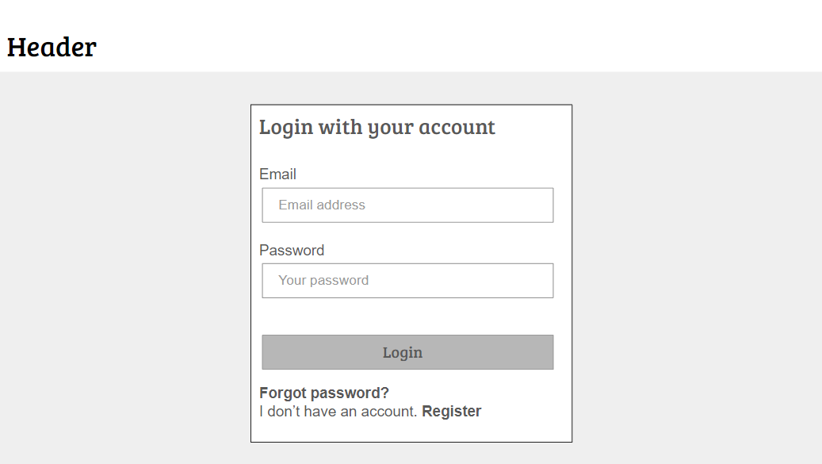

*Figure 2.4 Login screen*

* Function Details: User enters their email/username and password, then clicks the Login button to enter the homepage of the Website.
* Use-Case Description:

|  |  |
| --- | --- |
| Use Case ID | UC-03 |
| Use Case Name | Login |
| Actor | User, Admin |
| Description | This use case allows the user to register a new account which is used to access the system |
| Precondition | User has to have a valid account |
| Post-Condition | The system displays the relevent account |
| Main Flow | 1. User enters username, password  2. User submits username, password  3. The system vertifies username and password  4. Redirect users to the homepage  5. End of use case |
| Alternative flows | 3a. Username or password does not exist  1. Display "Invalid Username or Password" message  2. The use case resumes at main flow step 1 |

### 2.5. Forgot Password

* Function trigger: When user clicks to forgot password in Login screen.
* Function description:
  + Actors/Roles: Customer, Seller, Admin
  + Purpose: Users can change their passwords when they forget their old one
  + Data processing: Check the email of the user entered to see if it matches the registered email, if it is, the new password will be sent to the customer's email, if not, it will be required to re-enter.
* Screen layout:

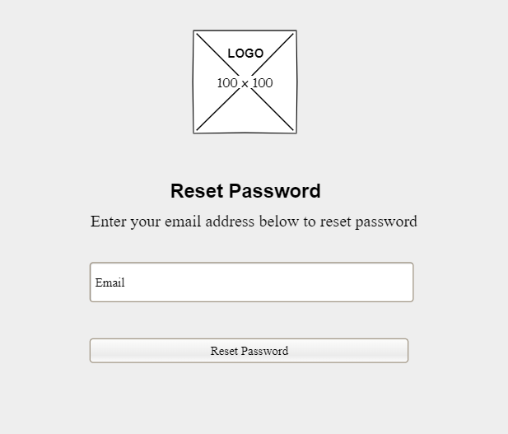

*Figure 2.5 Reset Password screen*

* Function Details: Users enter the email they used to register for an account, then the system will send a new password to the email and delete the old password.
* Use-Case Description:

|  |  |
| --- | --- |
| Use Case ID | UC-04 |
| Use Case Name | Forgot password |
| Actor | User |
| Description | This use case allows the user to retrieve the password when it is forgotten |
| Precondition | Have a valid registered email |
| Post-Condition | None |
| Main Flow | 1. Users enter their personal email used to register an account  2. Click the Reset Password button  3. The system will verify the email  4. The use case ends |
| Alternative flows | 3a. The email entered does not exist or is incorrect  1. Show "Incorrect email" message  2. The use case resumes at main flow step 1  3b. Accurate email confirmation system  1. Display the message "The system has sent a password to your email. Please check your email"  2. The use case ends |

### 2.6. View User Profile

* Function trigger: The user logs into the site, after that hovers over the person icon in the upper right corner and selects View profile.
* Function description:
  + Actors/Roles: Customer, Seller, Admin .
  + Purpose: Users can see their account’s detailed information.
  + Interface: There's a profile picture on the left side of the screen, details information in the middle, and About us on the right.
* Screen layout:

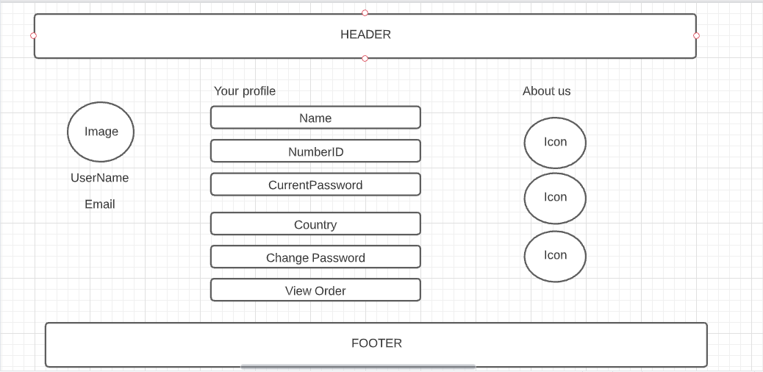

*Figure 2.6 User Profile screen*

* Function Details: Users can view their personal information.
* Use-Case Description:

|  |  |
| --- | --- |
| Use Case ID | UC-05 |
| Use Case Name | User Profile |
| Actor | User |
| Description | This use case allows the user to view a detailed profile page |
| Precondition | Have a valid login account |
| Post-Condition | None |
| Main Flow |  |
| Alternative flows |  |

### 2.7. Change Password

* Function trigger: When the user wants to change the account password.
* Function description:
  + Actors/roles: Customer, Seller, Admin
  + Purpose: User can change password.
  + Interface: Display form including: Current Password, New Password, Confirm New Password.
  + Data processing: Update client's current password.
* Screen layout:

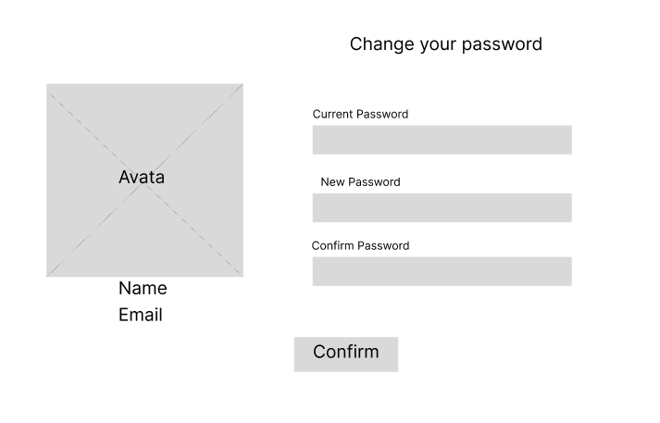

*Figure 2.7 Change Passowrd screen*

* Function Details: provide explanation for the data, validation, business logics, functionalities (for both normal cases and abnormal cases), etc. of the function so that the reader can image how it work
* Use-Case Diagram:
* Use-Case Description:

|  |  |
| --- | --- |
| Use Case ID | UC-06 |
| Use Case Name | Change password |
| Actor | User |
| Description | This use case allows user to change login password |
| Precondition | Have a valid login account |
| Post-Condition | None |
| Main Flow |  |
| Alternative flows |  |

### 2.8. Show Products (For user)

* Function trigger: Users visit the website then click on the product category name on the Home page or search for the product by name.
* Function description:
  + Actors/roles: Guest, Customer
  + Purpose: Allows users to filter product information, sort, view all available products, latest products, best sellers.
  + Interface: There is a search filter on the left side of the screen, the product list in the middle of the screen.
  + Data processing: The system will search according to the information provided by the user (retrieved from the search filter, product name, category).
* Screen layout:

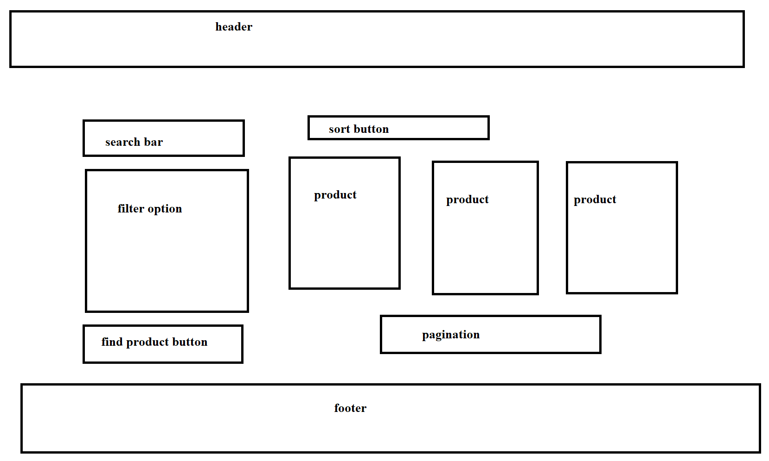

*Figure 2.8 Change Passowrd screen*

* Function Details: Display a detailed list of products for users to see.
* Use-Case Description:

|  |  |
| --- | --- |
| Use Case ID | UC-07 |
| Use Case Name | View Products |
| Actor | User |
| Description | This use case allows the user to see a list of products displayed on the online store |
| Precondition | None |
| Post-Condition | None |
| Main Flow | 1. Successfully accessed the online store using the link  2. Click on the Product link on navbar  3. The use case ends |
| Alternative flows | None |

### 2.9. View Product Detail (For user)

* Function trigger: User click on a Product in Product List.
* Function description:
  + Actors/roles: Guest, Customer.
  + Purpose: User can view all the detail information of a Product.
  + Interface: Title bar, product image on the left side of the screen, on the right side of the screen is the product name, price, quantity selection, 2 Add to Cart and Buy now buttons. Product description below.
  + Data processing: Get the number and size of products that the user chooses to save to the cart.
* Screen layout:

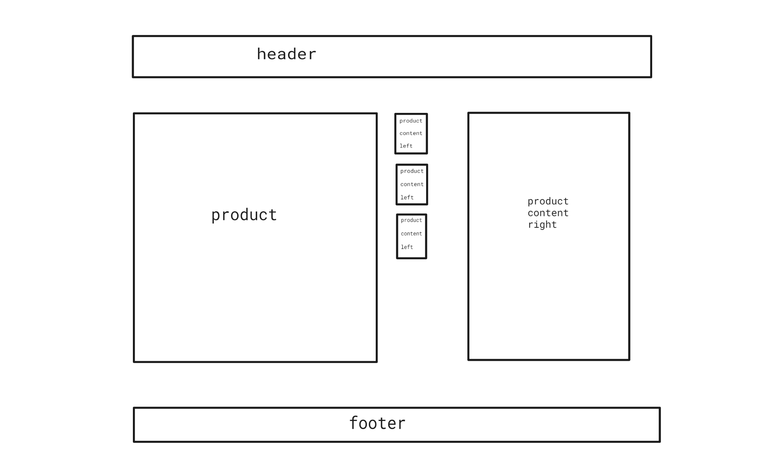

*Figure 2.9 Product Detail screen*

* Function Details: Display detailed information of the product to the user.
* Use-Case Description:

|  |  |
| --- | --- |
| Use Case ID | UC-08 |
| Use Case Name | Product Detail |
| Actor | User |
| Description | This use case allows the user to view detailed information of a product such as price, color, size, product description, etc. |
| Precondition | None |
| Post-Condition | None |
| Main Flow | 1. Successfully accessed the online store using the link  2. Click on the product name and photo to view detailed information  3. The use case ends |
| Alternative flows | None |

### 2.10. Add Address

* Function trigger: The user clicks on the Add new address button.
* Function description:
  + Actors/roles: Guest, Customer.
  + Purpose: Let the user to add personal addresses.
  + Interface: Have a button Add new Address.
  + Data processing: The data will be saved in the Address table in the Database.
* Screen layout:

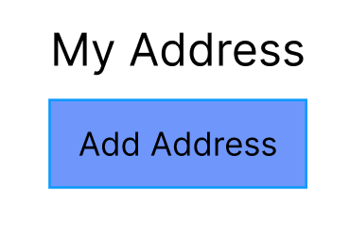

*Figure 2.10.1 Add Address button*

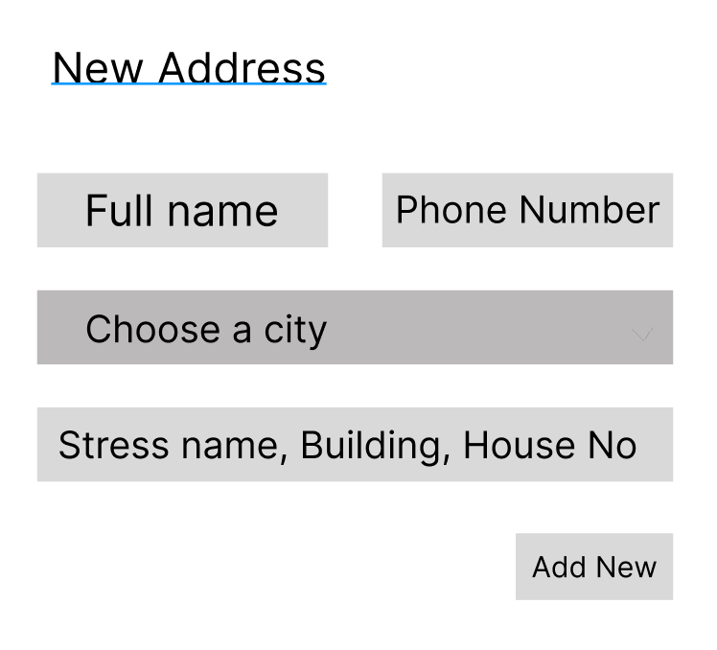

*Figure 2.10.2 Add Address modal (After clicking the button)*

* Function Details: Add a new user's personal address.
* Use-Case Description:

|  |  |
| --- | --- |
| Use Case ID | UC-09 |
| Use Case Name | Add Address |
| Actor | User |
| Description | This use case allows the user to add new user’s personal address |
| Precondition | None |
| Post-Condition | None |
| Main Flow | 1. Go to profile page  2. Click on the Address button  3. The screen displays as shown in Figure 2.10.1. Then click on the Add Address button  4. The display screen as shown in Figure 2.10.2  5. The use case ends |
| Alternative flows | None |

### 2.11. Edit Address

* Function trigger: The user clicks on the Edit button.
* Function description:
  + Actors/roles: Guest, Customer.
  + Purpose: Let the user to edit personal addresses.
  + Interface: Have a button Edit.
  + Data processing: The system will take the data saved in the Database and display it on the box. Then the user enters new information and Clicks on the Update button, the new data will be updated into the Database.
* Screen layout:

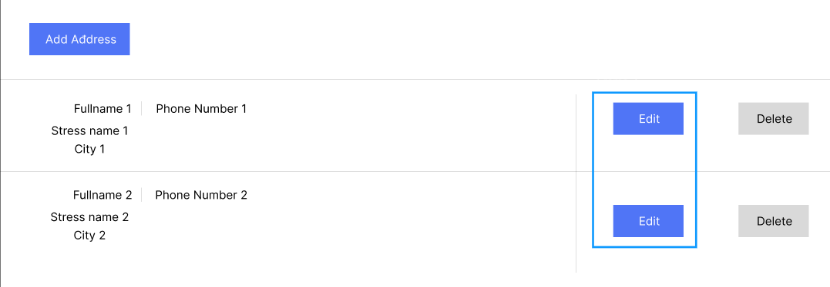

*Figure 2.11.1 Edit Address button (Green border)*

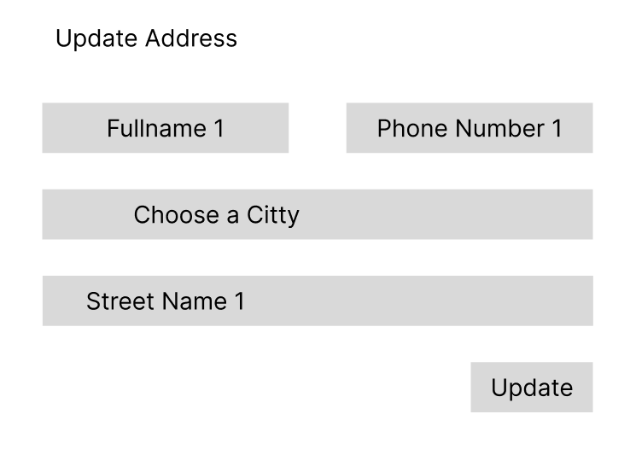

*Figure 2.11.2 Update Address modal (After clicking the Edit button)*

* Function Details: Add a new user's personal address.
* Use-Case Description:

|  |  |
| --- | --- |
| Use Case ID | UC-10 |
| Use Case Name | Edit Address |
| Actor | User |
| Description | This use case allows the user to re-edit his personal address |
| Precondition | None |
| Post-Condition | None |
| Main Flow | 1. Go to profile page  2. Click on the Address button  3. The screen displays as shown in Figure 2.11.1. Then click on the Edit Address button  4. The display screen as shown in Figure 2.11.2  5. The use case ends |
| Alternative flows | None |

### 2.12. Delete Address

* Function trigger: The user clicks on the Delete button.
* Function description:
  + Actors/roles: Guest, Customer.
  + Purpose: Allow users to delete addresses from the list.
  + Interface: Have a button Delete.
  + Data processing: The data will be deleted from the User Address table in the Database.
* Screen layout:

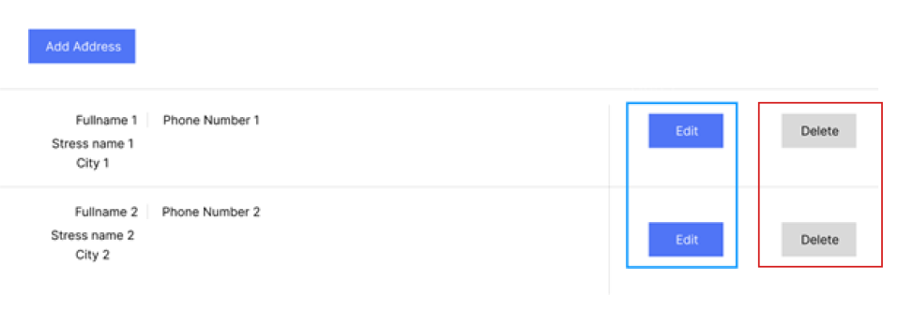

*Figure 2.12 Delete Address button (Red border)*

* Function Details: Add a new user's personal address.
* Use-Case Description:

|  |  |
| --- | --- |
| Use Case ID | UC-11 |
| Use Case Name | Delete Address |
| Actor | User |
| Description | This use case allows the user to delete his/her personal address |
| Precondition | None |
| Post-Condition | None |
| Main Flow | 1. Go to profile page  2. Click on the Address button  3. The screen displays as shown in Figure 2.12.1. Then click on the Delete Address button  4. The screen displays a message asking "Are you sure you want to delete this address?"  5. If "No" is selected, return to Main Flow 3, if "Yes" is selected, the address will be deleted  6. The use case ends |
| Alternative flows | None |

### 2.13. Update Profile

* Function trigger: Users who want to update their personal information.
* Function description:
  + Actors/roles: Guest, Customer.
  + Purpose: For users to update personal information such as full name, phone number, email, ...
  + Interface: There are 3 comboboxes that store full name, phone number, email and 2 radio for male and female gender, 1 button Save Profile.
  + Data processing: The data is stored in the Users table in the Database.
* Screen layout:

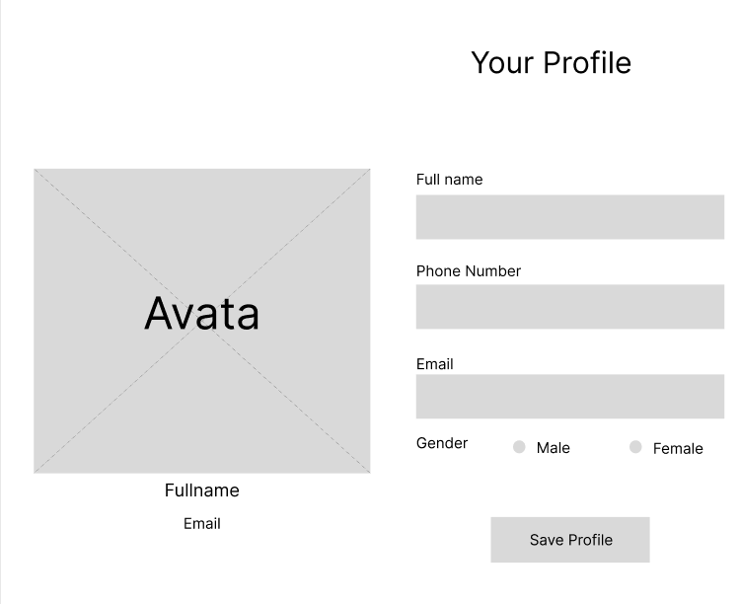

*Figure 2.13 Update Profile*

* Function Details: Update personal information.
* Use-Case Description:

|  |  |
| --- | --- |
| Use Case ID | UC-12 |
| Use Case Name | Update Profile |
| Actor | User |
| Description | This use case allows the user to update personal information |
| Precondition | None |
| Post-Condition | None |
| Main Flow | 1. Click on the link to go to User Profile  2. Display the screen as shown in Figure 2.11  3. Enter information fields in the boxes  4. Click the Save Profile button  5. The use case ends |
| Alternative flows | 3a. Enter the wrong phone number format  1. Show "Phone Format error" error message  2. Go back to Main flow step 3  3b. Enter the wrong email format  1. Show "Email Format error" error message  2. Go back to Main flow step 3 |

### 2.14. Add to Cart

* Function trigger: When the user clicks the Add to Cart button on the product detail page.
* Function description:
  + Actors/roles: Guest, Customer.
  + Purpose: Add products to your cart.
  + Interface: There is 1 button.
  + Data processing: When the user clicks the button, the system will save the product's information in the cookie.
* Screen layout:

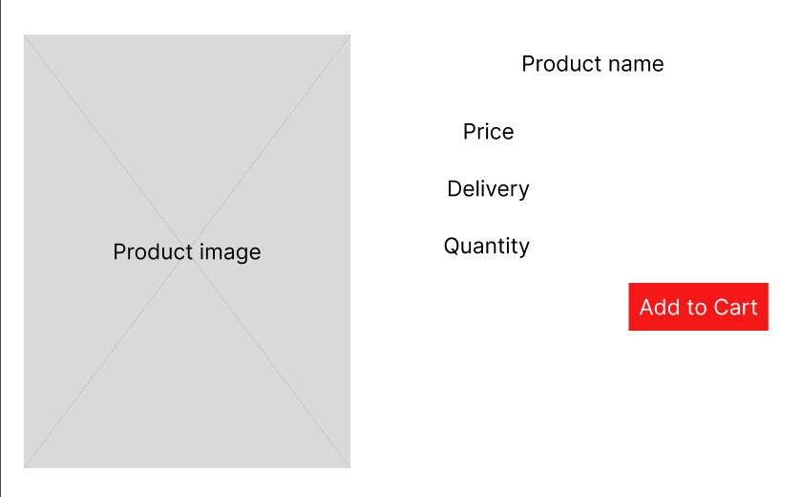

*Figure 2.14 Add to Cart button*

* Function Details: Users will add their products to the cart.
* Use-Case Description:

|  |  |
| --- | --- |
| Use Case ID | UC-13 |
| Use Case Name | Add to cart |
| Actor | User |
| Description | The function allows users to save products to the cart before proceeding to checkout |
| Precondition | None |
| Post-Condition | None |
| Main Flow | 1. Select the number of products you want to buy  2. Click the Add to Cart button  3. End of the Use-Case |
| Alternative flows | None |

### 2.15. View cart

* Function trigger: When the user clicks on the Cart icon, the system will take the user to the Cart shopping detail page.
* Function description:
  + Actors/roles: Guest, Customer.
  + Purpose: View all products added to cart.
  + Interface: There is a small product image, name, quantity, product price, a form to enter the delivery address, an invoice stating the total amount of the order. 1 button to return to Products page and 1 button to Checkout.
  + Data processing: Calculate the total amount of the order.
* Screen layout:

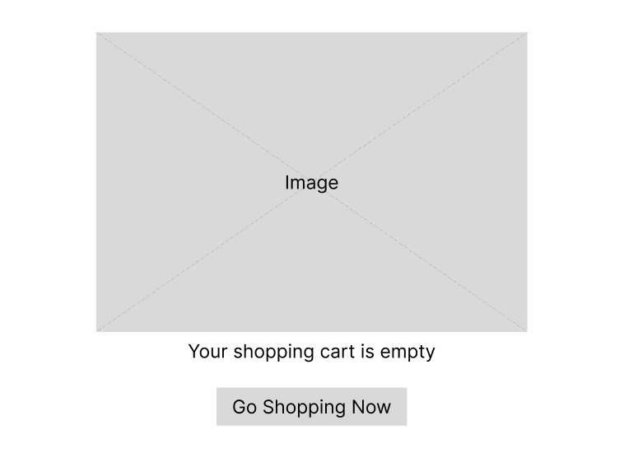

*Figure 2.15.1 Shopping Cart screen (Is empty)*

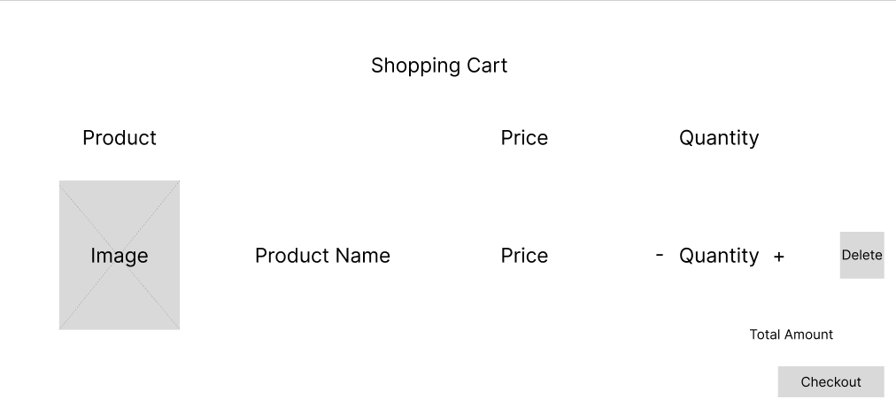

*Figure 2.15.2 Shopping Cart screen (There are products in the cart)*

* Function Details: Show the user the list of products in the cart.
* Use-Case Description:

|  |  |
| --- | --- |
| Use Case ID | UC-14 |
| Use Case Name | View cart |
| Actor | User |
| Description | Show the list of products saved in the cart |
| Precondition | None |
| Post-Condition | None |
| Main Flow | 1. Click on the Cart icon  2. End of the Use-Case |
| Alternative flows | None |

### 2.16. Delete Product in Cart

* Function trigger: When the user does not want to pay for the product, press the Delete button to remove it from the cart.
* Function description:
  + Actors/roles: Guest, Customer.
  + Purpose: User wants to remove product from cart.
  + Interface: 1 button Delete.
  + Data processing: Delete products stored in cookies.
* Screen layout: mockup prototype of the screen, sample below is for Manage Products screen

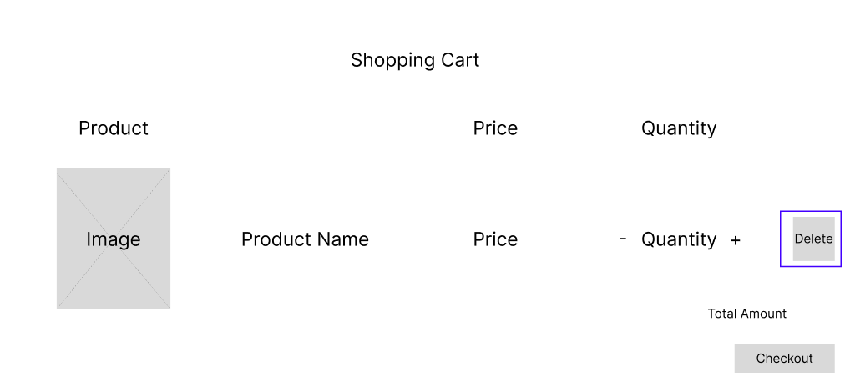

*Figure 2.16 Delete Product (Green border)*

* Function Details: Remove product from cart.
* Use-Case Description:

|  |  |
| --- | --- |
| Use Case ID | UC-15 |
| Use Case Name | Delete Product in Cart |
| Actor | User |
| Description | Allow user to remove 1 product from cart |
| Precondition | None |
| Post-Condition | None |
| Main Flow | 1. Click the Delete button  2. The system will delete the product data stored in the cookie  3. End of the Use-Case |
| Alternative flows | None |

### 2.17. CheckOut

* Function trigger: User wants to order product.
* Function description:
  + Actors/roles: Customer.
  + Purpose: Create product orders.
  + Interface: 1 button CheckOut.
  + Data processing: None.
* Screen layout:

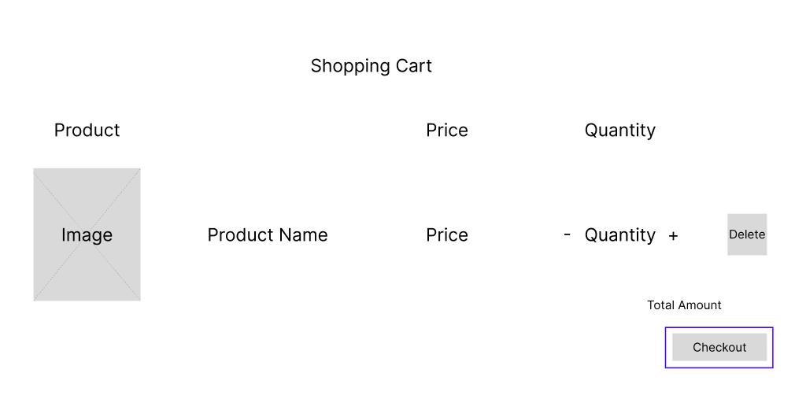

*Figure 2.17 CheckOut button (Green border)*

* Function Details: Create product orders.
* Use-Case Description:

|  |  |
| --- | --- |
| Use Case ID | UC-16 |
| Use Case Name | Check Out |
| Actor | User |
| Description | The function allows users to create an order before making payment |
| Precondition | None |
| Post-Condition | None |
| Main Flow | 1. Change the number of products you want to buy in the cart  2. Click the CheckOut button  3. End of the Use-Case |
| Alternative flows | None |

### 2.18. Place Order

* Function trigger: User wants to pay for the order.
* Function description:
  + Actors/roles: Customer.
  + Purpose: Payment processing for orders.
  + Interface: 1 button Place Order
  + Data processing: The data including userID, address, note, order creation date, and the default order status will be "Waiting for confirmation" will be stored in the Order table in the Database.
* Screen layout:

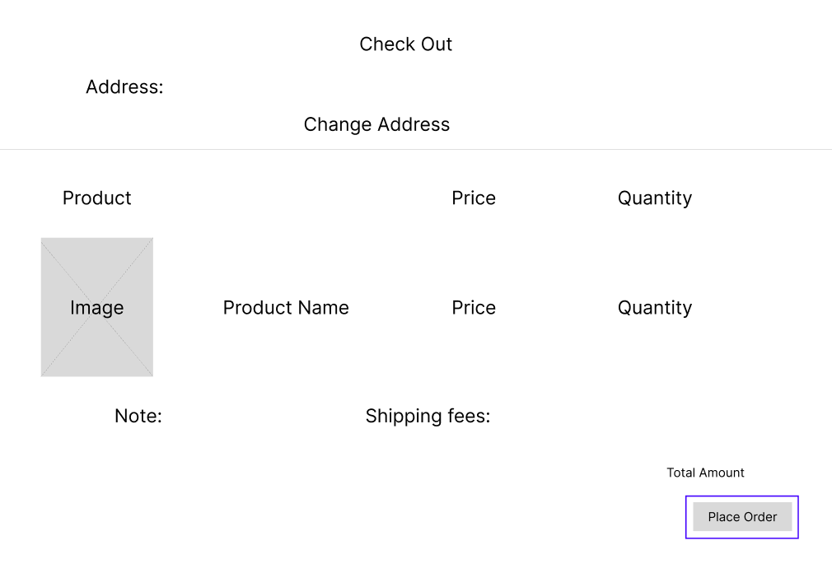

*Figure 2.18 Place Order (Green border)*

* Function Details: Create an order.
* Use-Case Description:

|  |  |
| --- | --- |
| Use Case ID | UC-17 |
| Use Case Name | Place Order |
| Actor | User |
| Description | Allow users to proceed to create an order |
| Precondition | None |
| Post-Condition | None |
| Main Flow | 1. Choose an address for the seller to ship to  2. Click the Place Order button  3. Display the screen saying "Success"  4. End of the Use-Case |
| Alternative flows | None |

### 2.19. View order

* Function trigger: User wants to view his order by clicking View My Orders on Profile page.
* Function description:
  + Aactors/roles: Customer.
  + Purpose: Double check the orders.
  + Interface: The table contains information of the order including order code, order status (Pending confirmation), order creation date, order details (View link) and Cancel button.
  + Data processing: Load data from the Order Detail table in the database to display on the website.
* Screen layout:

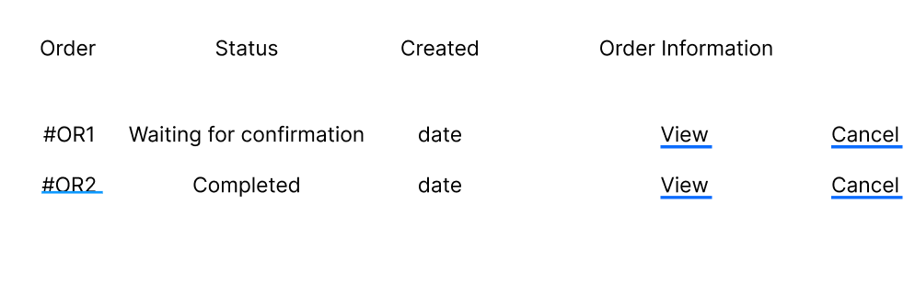

*Figure 2.19 View Order screen*

* Function Details: Displays a list of orders that have been placed.
* Use-Case Description:

|  |  |
| --- | --- |
| Use Case ID | UC-18 |
| Use Case Name | View order |
| Actor | User |
| Description | Show users a list of orders placed |
| Precondition | None |
| Post-Condition | None |
| Main Flow | 1. Click the View Orders button on your profile page  2.End of the Use-Case |
| Alternative flows | None |

### 2.20. View Order Detail

* Function trigger: Users log-in to the website, access My Orders page and click View button.
* Function description:
  + Actors/roles: Customer.
  + Purpose: See the order detailed information.
  + Interface: The table contains the details of the order.
  + Data processing: Load data from the Order Detail table in the database onto the website.
* Screen layout:

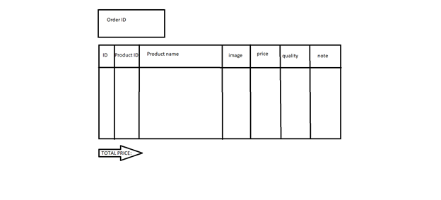

*Figure 2.20 View Order Detail screen*

* Function Details: Display details of products included in the order.
* Use-Case Description:

|  |  |
| --- | --- |
| Use Case ID | UC-19 |
| Use Case Name | View order detail |
| Actor | User |
| Description | Displays a list of orders the user has ordered |
| Precondition | None |
| Post-Condition | None |
| Main Flow | 1. Click on the "View" link on the View Order page  2. End of the Use-Case |
| Alternative flows | None |

### 2.21. Add Wishlist

* Function trigger: When the user clicks the Add to Your Wishlist button on the product detail page.
* Function description:
  + Actors/roles: Guest, Customer.
  + Purpose: Add products to your wishlist.
  + Interface: There is 1 button.
  + Data processing: When the user clicks the button, the system will save the product's information in the Favorite Product table in the database.
* Screen layout:

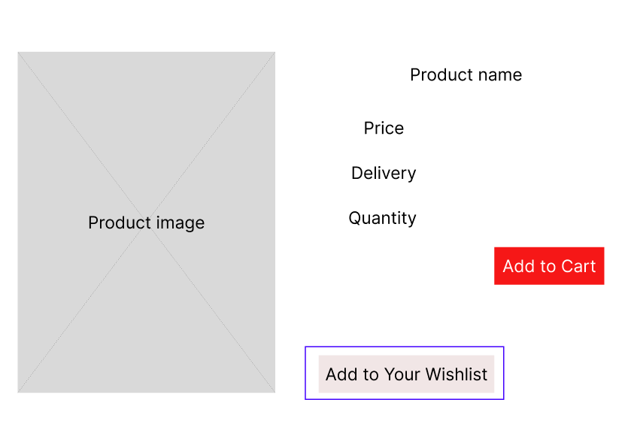

*Figure 2.21 Add to Your Wishlist button (Green border)*

* Function Details: The function allows users to add products that they love to the list.
* Use-Case Description:

|  |  |
| --- | --- |
| Use Case ID | UC-20 |
| Use Case Name | Add to Wishlist |
| Actor | User |
| Description | The function allows users to add products that they love to the list |
| Precondition | None |
| Post-Condition | None |
| Main Flow | 1. Click the button "Add to your wishlist"  2. End of the Use-Case |
| Alternative flows | None |

### 2.22. My Wishlist

* Function trigger: When the user clicks the My Wishlist button on the profile.
* Function description:
  + Actors/roles: Guest, Customer.
  + Purpose: Show list of user's favorite products.
  + Interface: There is 1 button.
  + Data processing: Load data from the Favorite Product table in the database onto the website.
* Screen layout:

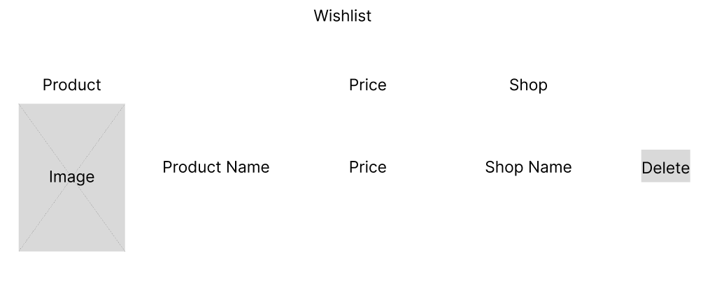

*Figure 2.22 My Wishlist screen*

* Function Details: Users will add their products to the cart.
* Use-Case Description:

|  |  |
| --- | --- |
| Use Case ID | UC-21 |
| Use Case Name | My Wishlist |
| Actor | User |
| Description | This function allows users to view a list of their favorite products after learning to add them to the favorite list |
| Precondition | None |
| Post-Condition | None |
| Main Flow | 1. Click the My Wishlist button in the profile page  2. End of the Use-Case |
| Alternative flows | None |

### 2.23. Delete product in "My Wishlist"

* Function trigger: When the user clicks the button Delete in “My Wishlist”.
* Function description:
  + Actors/roles: Guest, Customer.
  + Purpose: Remove 1 product from wishlist.
  + Interface: There is 1 button.
  + Data processing: The system will delete the data in the Favorite Product table in the database.
* Screen layout:

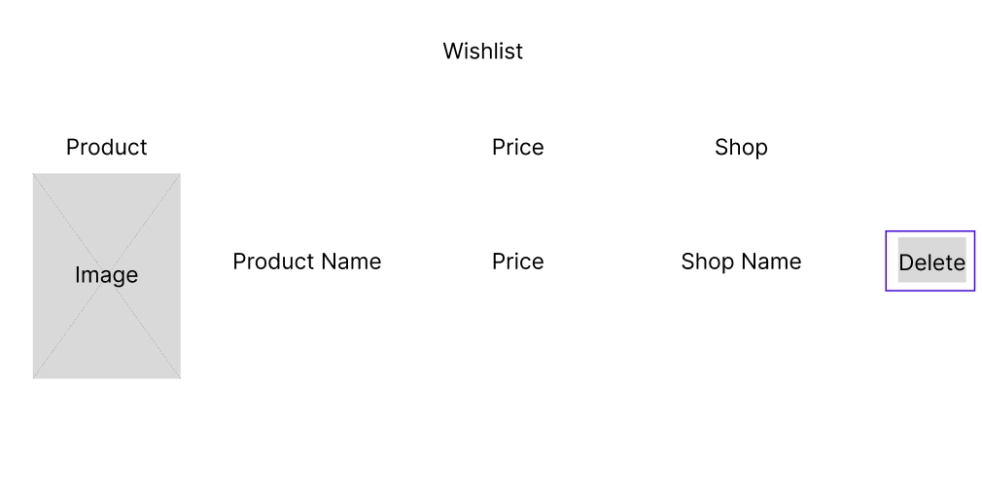

*Figure 2.23 Delete button (Green border)*

* Function Details: Users will add their products to the cart.
* Use-Case Description:

|  |  |
| --- | --- |
| Use Case ID | UC-22 |
| Use Case Name | Delete product in My Wishlist |
| Actor | User |
| Description | This function allows the user to remove 1 product from the favorites list |
| Precondition | None |
| Post-Condition | None |
| Main Flow | 1. Tap the trash can icon at the bottom of each product in the favorites list to delete it  2. The system will display a message asking if the user is sure he wants to remove the product from the list  3. End of the Use-Case |
| Alternative flows | None |

### 2.24. Add Feedback

* Function trigger: When the user receives the goods, click on My order and then click on Feedback and evaluate.
* Function description:
  + Actors/roles: Customer.
  + Purpose: Customer writes and send a Feedback about a Product.
  + Interface: Choose a star to show your product satisfaction, a feedback box, and a Submit button.
  + Data processing: The system will update the user's feedback in the Feedback table in the database including User ID, product ID, order ID, number of stars and feedback.
* Screen layout:

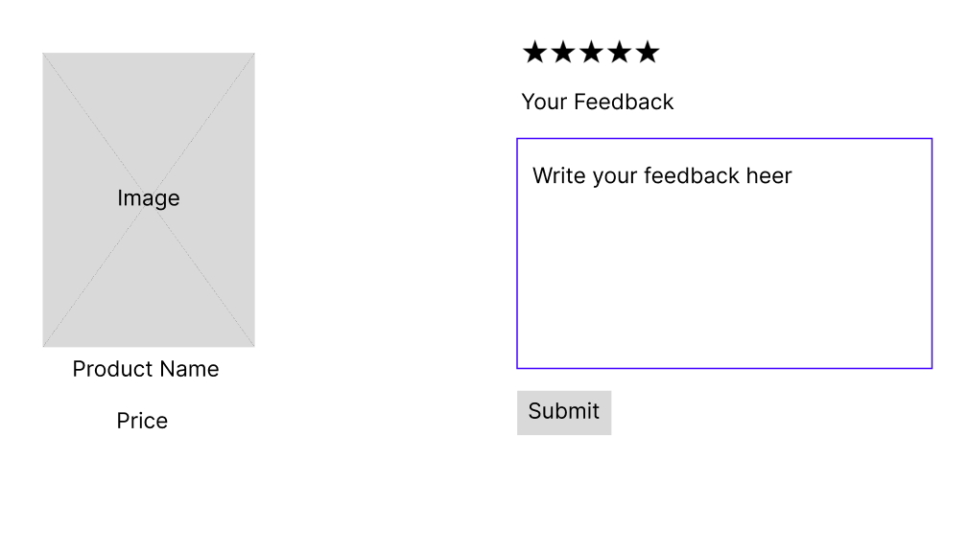

*Figure 2.24 Add Feedback screen*

* Function Details: Allows users to submit product feedback reviews after receiving the item.
* Use-Case Description:

|  |  |
| --- | --- |
| Use Case ID | UC-23 |
| Use Case Name | Add Feedback |
| Actor | User |
| Description | The function that allows users to submit product feedback reviews |
| Precondition | None |
| Post-Condition | None |
| Main Flow | 1. Choose number of stars  2. Write a review  3. Click the "Submit" button to submit a review  4. End of the Use-Case |
| Alternative flows | None |

### 2.25. View Feedback (For user)

* Function trigger: Customers click on the Feedback link to see other people's reviews.
* Function description:
  + Actors/roles: Guest, Customer.
  + Purpose: See all comments by other users.
  + Interface: Username, rating stars and reviews.
  + Data processing: Load data from the "Feedback" table in the database into the web page.
* Screen layout:

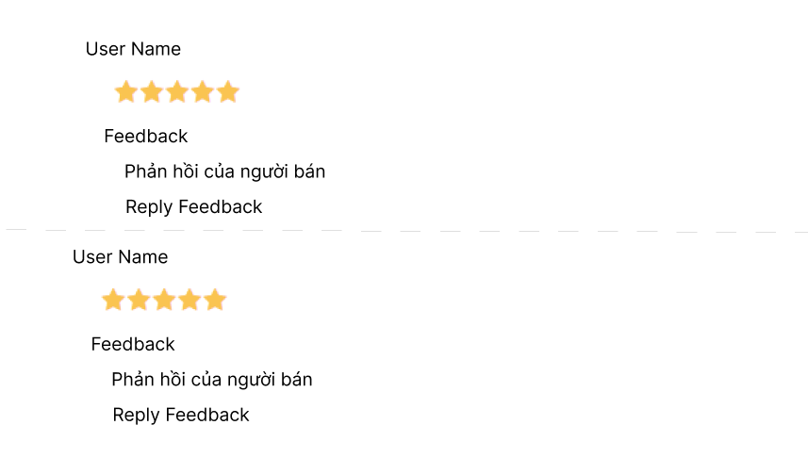

*Figure 2.25 View Feedback screen*

* Function Details: Show users all comments, star reviews from other customers.
* Use-Case Description:

|  |  |
| --- | --- |
| Use Case ID | UC-24 |
| Use Case Name | View Feedback |
| Actor | User |
| Description | Show users all comments, star reviews from other customers |
| Precondition | None |
| Post-Condition | None |
| Main Flow | 1. Click on the "Feedback" link  2.End of the Use-Case |
| Alternative flows | None |

### 2.26. Blogs List

* Function trigger: User click Blogs on menu bar in Homepage.
* Function description:
  + Aactors/roles: Guest, Customer.
  + Purpose: Customer views the list of all Blogs.
  + Interface: There are pictures and intro.
  + Data processing: Load data from Blog table in database onto website.
* Screen layout:

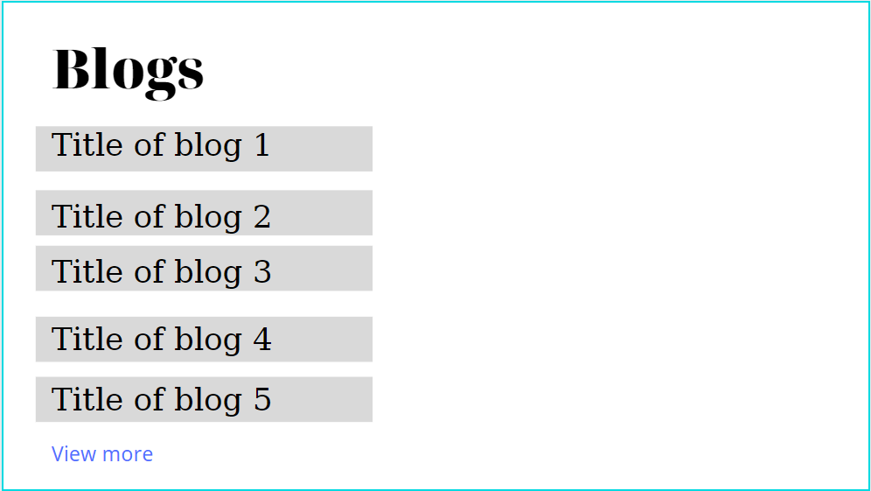

*Figure 2.26 Blogs screen*

* Function Details: Display list of all Blogs.
* Use-Case Description:

|  |  |
| --- | --- |
| Use Case ID | UC-25 |
| Use Case Name | Blog list |
| Actor | User |
| Description | This use case allows the user to see a list of Blogs posted by the seller |
| Precondition | None |
| Post-Condition | None |
| Main Flow | 1. Users access the store on the Website according to the link  2. Click the Blog link on the navigation bar  3. The use case ends |
| Alternative flows | None |

### 2.27. Blogs Detail

* Function trigger: User click Blogs on menu bar in Homepage, then click on Blogs they want to see detail.
* Function description:
  + Aactors/roles: Guest, Customer.
  + Purpose: Customer views the Detail information of 1 Blog.
  + Interface: There are pictures, title of Blogs, intro, author.
  + Data processing: Load data from Blog Detail table in database onto website
* Screen layout:

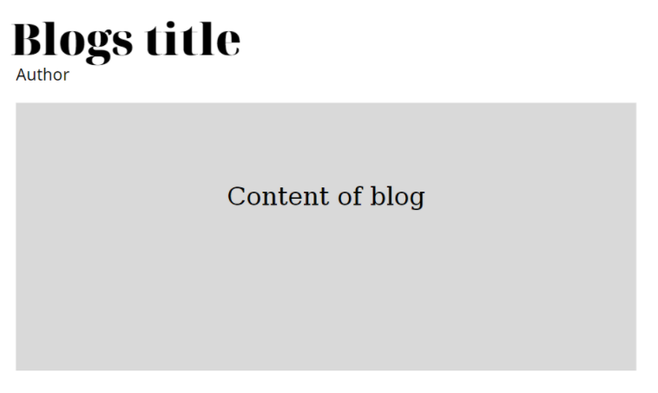

*Figure 2.27 Blogs Detail screen*

* Function Details: Display detail of 1 Blogs.
* Use-Case Description:

|  |  |
| --- | --- |
| Use Case ID | UC-26 |
| Use Case Name | Blog Detail |
| Actor | User |
| Description | This use case allows the user to view detailed information of the Blog including the Blog's author name, the date of writing, the Blog's content |
| Precondition | None |
| Post-Condition | None |
| Main Flow | 1. Users access the store on the Website according to the link  2. Click the Blog link on the navigation bar  3. Click on Blog's name, image or "Read More" redirect  4. The use case ends |
| Alternative flows | None |

### 2.28. Search Blogs (For User)

* Function trigger: Enter the name of the blog post, the author's name in the search box.
* Function description:
  + Aactors/roles: Guest, Customer.
  + Purpose: Quickly Search Blog Posts.
  + Interface: There is a search box.
  + Data processing: Perform a search query in the database: Search by Blog name, author name, or content.
* Screen layout:

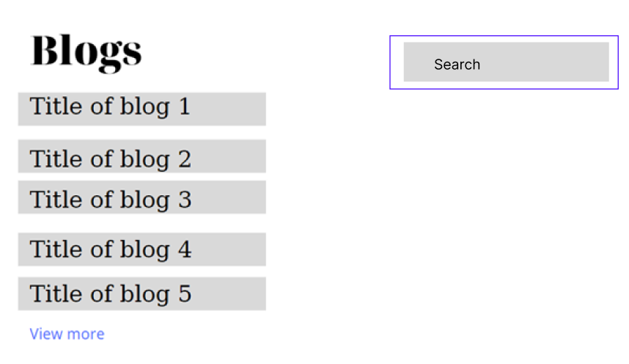

*Figure 2.28 Search Blog (Green border)*

* Function Details: Allows users to search Blogs.
* Use-Case Description:

|  |  |
| --- | --- |
| Use Case ID | UC-27 |
| Use Case Name | Search Blogs |
| Actor | User |
| Description | This use case allows the user to perform a search for the desired Blog post title |
| Precondition | None |
| Post-Condition | None |
| Main Flow | 1. Enter the search text in the search box  2. Click the magnifying glass icon  3. The use case ends |
| Alternative flows | None |

### 2.29. View Service

* Function trigger: User click Service on menu bar in Homepage.
* Function description:
  + Aactors/roles: Customer, Seller, Admin.
  + Purpose: User views the list of all Service.
  + Interface: There is a search box.
  + Data processing: Load data from HelpCategory, HelpTitle, HelpContent tables in the database onto the web page.
* Screen layout:

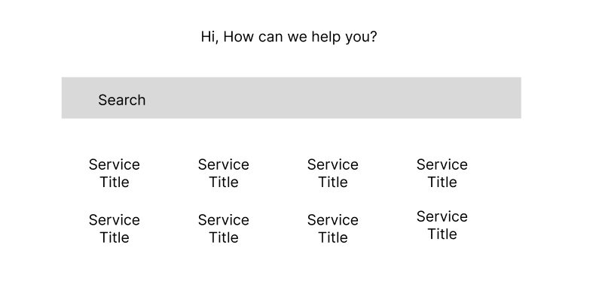

*Figure 2.29.1 View Service Title screen*

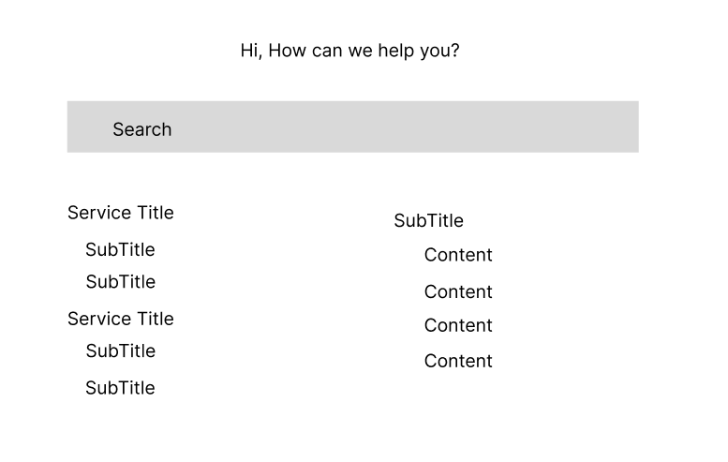

*Figure 2.29.2 View Service Content screen*

* Function Details: Display list of all Service.
* Use-Case Description:

|  |  |
| --- | --- |
| Use Case ID | UC-28 |
| Use Case Name | View Service |
| Actor | User |
| Description | Display list of all Service |
| Precondition | None |
| Post-Condition | None |
| Main Flow | 1. Click the Service link on the navigation bar  2. Click on each Service Title to show Service Content  3. End of the Use-Case |
| Alternative flows | None |

### 2.30. Search Service

* Function trigger: Enter the search text in the search box.
* Function description:
  + Aactors/roles: Customer, Seller, Admin.
  + Purpose: Search the site's services.
  + Interface: There is a search box.
  + Data processing: Perform a search statement between 3 tables in the database.
* Screen layout:

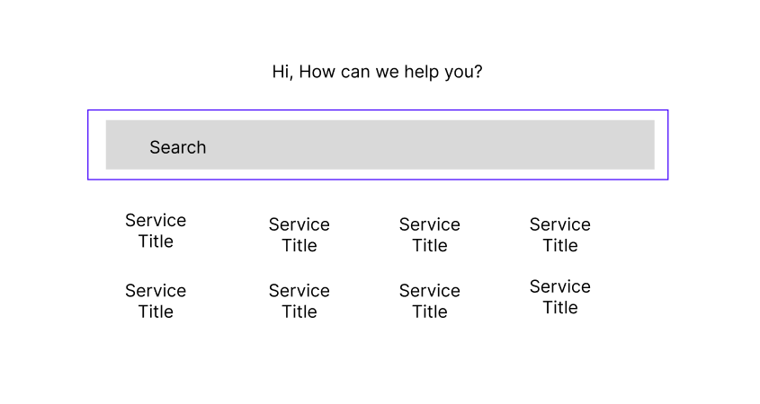

*Figure 2.30.1 Search Service in screen Title (Green border)*

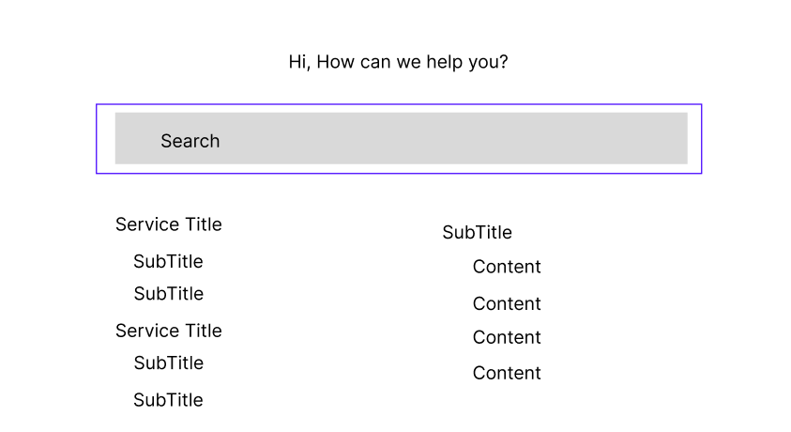

*Figure 2.30.2 Search Service in screen Content (Green border)*

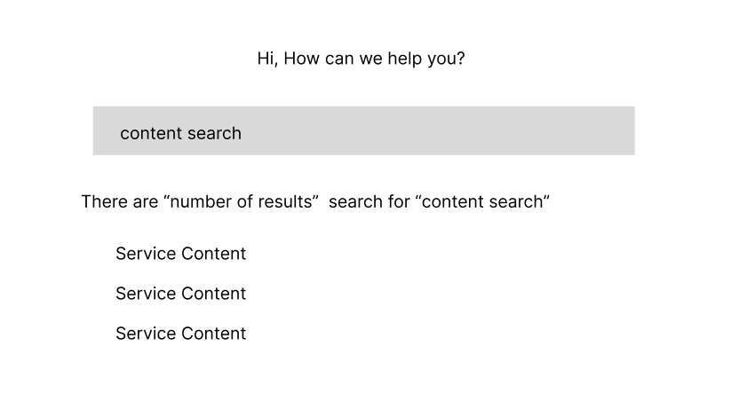

*Figure 2.30.3 Search Results screen*

* Function Details: Search Service.
* Use-Case Description:

|  |  |
| --- | --- |
| Use Case ID | UC-29 |
| Use Case Name | View Service |
| Actor | User |
| Description | Allow users to search for support content |
| Precondition | None |
| Post-Condition | None |
| Main Flow | 1. Enter the search text in the search box  2. Click on the magnifying glass icon  3. End of the Use-Case |
| Alternative flows | None |

### 2.31. Search Products

* Function trigger: User logs-in the website, clicks on the text “Mark all as read”.
* Function description:
  + Aactors/roles: Customer, Seller, Admin.
  + Purpose: Search for products.
  + Interface: There is a search box.
  + Data processing: Execute a search statement in the Product table in the database.
* Screen layout:

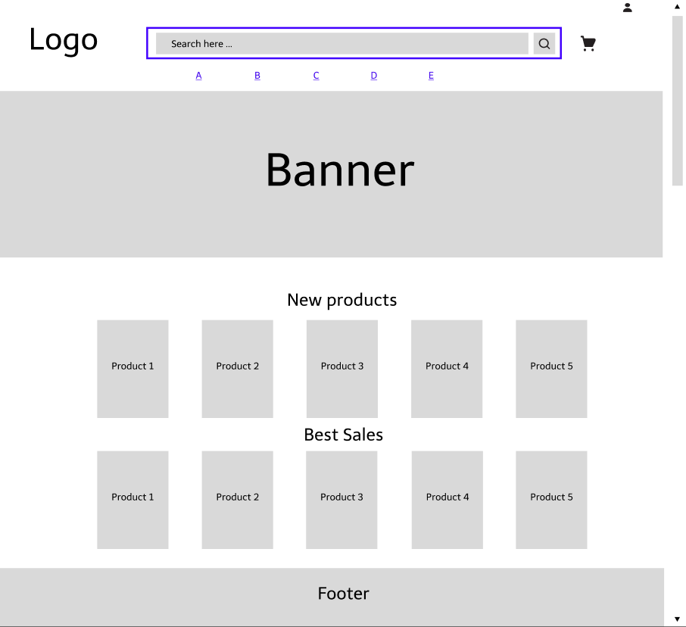

*Figure 2.31.1 Search Products in Homepage (Green border)*

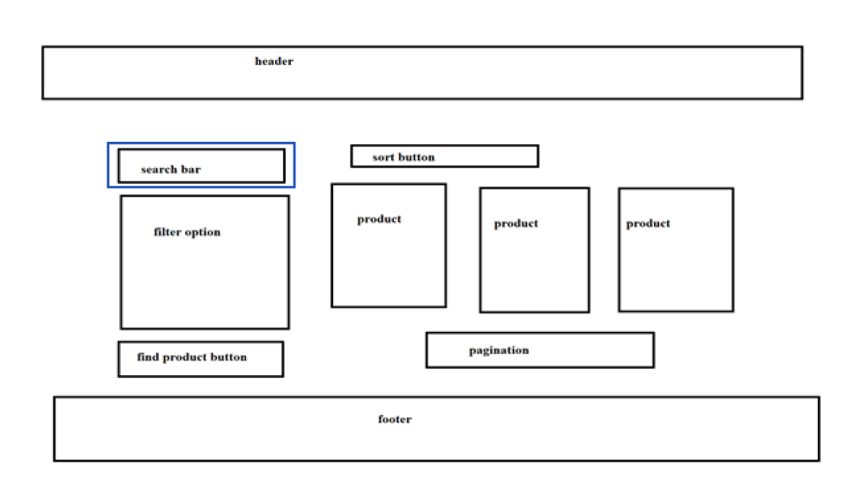

*Figure 2.31.2 Search Products in Products page (Green border)*

* Function Details: Search Products by name.
* Use-Case Description:

|  |  |
| --- | --- |
| Use Case ID | UC-30 |
| Use Case Name | Search Products |
| Actor | User |
| Description | Allow users to search products in Homepage, Products page |
| Precondition | None |
| Post-Condition | None |
| Main Flow | 1. Enter the search text in the search box  2. Click on the magnifying glass icon  3. End of the Use-Case |
| Alternative flows | None |

### 2.32. Admin Dashboard

* Function trigger: Admin login successfully then access the management page.
* Function description:
  + Actors/roles: Admin
  + Purpose: Allow admin can view detailed statistics, revenue, website visitors.
* Screen layout:

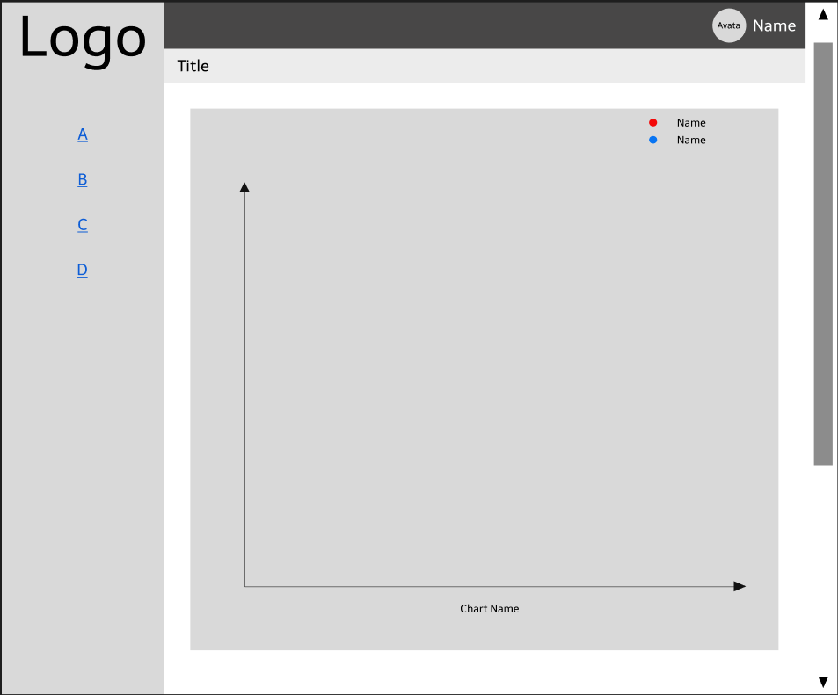

*Figure 2.32 Admin Dashboard screen*

* Function Details: View detailed statistics, website visitors, revenue.
* Use-Case Description:

|  |  |
| --- | --- |
| Use Case ID | UC-31 |
| Use Case Name | Admin Dashboard |
| Actor | Admin |
| Description | Allow Admin to view detailed website statistics |
| Precondition | None |
| Post-Condition | None |
| Main Flow | 1. Login with Admin account  2. Click the Dashboard link in the navbar  3. End of the Use-Case |
| Alternative flows | None |

### 2.33. List of Account (Admin)

* Function trigger: Admin login successfully then access the View Account Manage page.
* Function description:
  + Actors/roles: Admin
  + Purpose: Allow Admin to see the list of registered accounts.
  + Data processing: Load data from the Users table in the database.
* Screen layout:

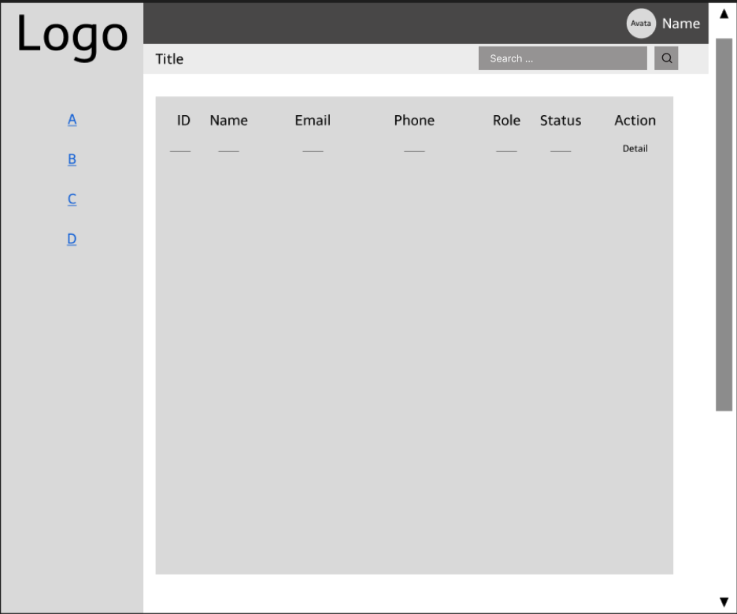

*Figure 2.33 Account Management screen*

* Function Details: View the list of accounts registered on the system.
* Use-Case Description:

|  |  |
| --- | --- |
| Use Case ID | UC-32 |
| Use Case Name | Account Management |
| Actor | Admin |
| Description | Allow Admin to view list all accounts registered |
| Precondition | None |
| Post-Condition | None |
| Main Flow | 1. Login with Admin account  2. Click the Manage Account link on the left side of the navigation bar  3. End of the Use-Case |
| Alternative flows | None |

### 2.34. Account Information (Admin)

* Function trigger: When the admin is on the View Account page, click on the Individual icon to view the user's details.
* Function description:
  + Actors/roles: Admin.
  + Purpose: Allows administrators to view detailed account information of customers, seller, other admins or personal information.
  + Data processing: Get the data in the User table in the database according to the User ID code to display the details of the account with that User ID code.
* Screen layout:

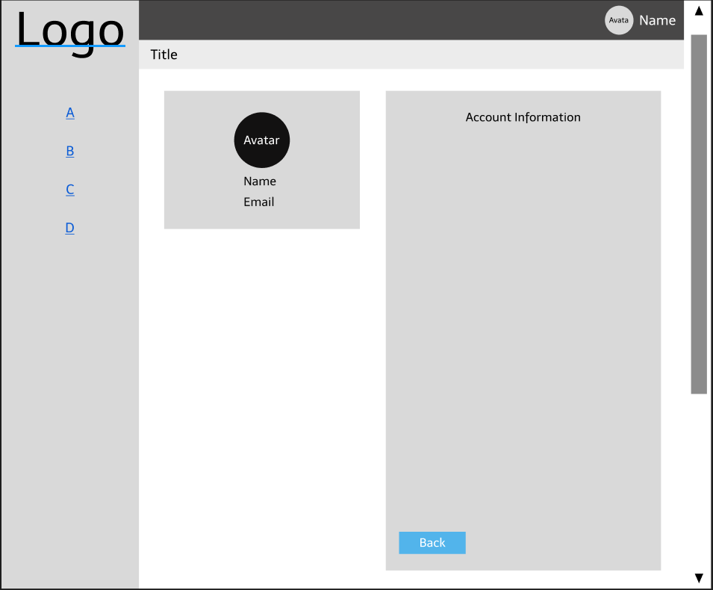

*Figure 2.34 Account Information screen*

* Function Details: View detailed account information of customers, sellers, admin.
* Use-Case Description:

|  |  |
| --- | --- |
| Use Case ID | UC-33 |
| Use Case Name | Account Management |
| Actor | Admin |
| Description | Allows administrators to view user account details |
| Precondition | None |
| Post-Condition | None |
| Main Flow | 1. Click the Manage Account link on the left side of the navigation bar  2. Click on the humanoid icon in the Action column to view account details  3. End of the Use-Case |
| Alternative flows | None |

### 2.35. Search Account (Admin)

* Function trigger: Admin enter the account name in the Search bar and click the magnifying glass button on the upper right hand side of the screen.
* Function description:
  + Actors/roles: Admin.
  + Purpose: Allow admin to search user's account name when there are too many accounts stored in the system.
  + Data processing: Use the search command in the Users table in the database to search for accounts by account name, username, role.
* Screen layout:



*Figure 2.35 User's Account Search (Search box)*

* Function Details: User Account Search.
* Use-Case Description:

|  |  |
| --- | --- |
| Use Case ID | UC-34 |
| Use Case Name | Search Account |
| Actor | Admin |
| Description | Allows administrators to search user account |
| Precondition | None |
| Post-Condition | None |
| Main Flow | 1. Enter the search text in the search box  2. Click on the magnifying glass icon  3. End of the Use-Case |
| Alternative flows | None |

### 2.36. List of Shops (Admin)

* Function trigger: Admin login successfully then access the View Shop Manage page.
* Function description:
  + Actors/roles: Admin
  + Purpose: Allow Admin to see the list of Shops.
  + Data processing: Load data from the Users table in the database.
* Screen layout:



*Figure 2.36 Shop Management screen*

* Function Details: See the store list of those who have registered as a seller.
* Use-Case Description:

|  |  |
| --- | --- |
| Use Case ID | UC-35 |
| Use Case Name | Shop Management |
| Actor | Admin |
| Description | Allow Admin to view store list of those who have registered as a seller |
| Precondition | None |
| Post-Condition | None |
| Main Flow | 1. Login with Admin account  2. Click the Manage Shop link on the left side of the navigation bar  3. End of the Use-Case |
| Alternative flows | None |

### 2.37. Shop Information (Admin)

* Function trigger: When the admin is on the List of Shop page, click on the Individual icon to view the shop's details.
* Function description:
  + Actors/roles: Admin.
  + Purpose: Allows administrators to view detailed shop information of seller.
  + Data processing: Get data in 3 tables Users, Shop and Products in the database to display detailed information of that shop (Store owner, shop owner phone number, email, total number of products).
* Screen layout:



*Figure 2.37 Shop Information screen*

* Function Details: View store details.
* Use-Case Description:

|  |  |
| --- | --- |
| Use Case ID | UC-36 |
| Use Case Name | Shop Management |
| Actor | Admin |
| Description | Allows admin to view seller's store details |
| Precondition | None |
| Post-Condition | None |
| Main Flow | 1. Click the Manage Shop link on the left side of the navigation bar  2. Click the eye icon in the Actions column to view store details  3. End of the Use-Case |
| Alternative flows | None |

### 2.38. Search Shop (Admin)

* Function trigger: Admin enter the shop name in the Search bar and click the magnifying glass button on the upper right hand side of the screen.
* Function description:
  + Actors/roles: Admin.
  + Purpose: Allow admin to search shopname when there are too many shop stored in the system.
  + Data processing: Use the search command in the database to search for shops by shop name, shop owner's name.
* Screen layout:



*Figure 2.38 Shop search (Search box)*

* Function Details: Search 1 store.
* Use-Case Description:

|  |  |
| --- | --- |
| Use Case ID | UC-37 |
| Use Case Name | Search Shop |
| Actor | Admin |
| Description | Allows administrators to search shop |
| Precondition | None |
| Post-Condition | None |
| Main Flow | 1. Enter the search text in the search box  2. Click on the magnifying glass icon  3. End of the Use-Case |
| Alternative flows | None |

### 2.39. Report from User (Admin)

* Function trigger: Admin clicks on Report from user link.
* Function description:
  + Actors/roles: Admin.
  + Purpose: Allows administrators to view a list of reports submitted by users.
  + Data processing: Load data from the Report table in the database.
* Screen layout:

*Figure 2.39 List of Report from Users screen*

* Function Details: View reports sent from users.
* Use-Case Description:

|  |  |
| --- | --- |
| Use Case ID | UC-38 |
| Use Case Name | Report from Users |
| Actor | Admin |
| Description | View reports sent from users |
| Precondition | None |
| Post-Condition | None |
| Main Flow | 1. Login with Admin account  2. Click the Report from Users link on the left side of the navigation bar  3. End of the Use-Case |
| Alternative flows | None |

### 2.40. Search Report (Admin)

* Function trigger: Admin enter the report in the Search bar and click the magnifying glass button on the upper right hand side of the screen.
* Function description:
  + Actors/roles: Admin.
  + Purpose: Allows administrators to search for reports when too many reports are sent to the system.
  + Data processing: Use the search command in the database to search for user reports (Find by sender name, report title or body).
* Screen layout:



*Figure 2.40 Report search (Search box)*

* Function Details: Search 1 report.
* Use-Case Description:

|  |  |
| --- | --- |
| Use Case ID | UC-39 |
| Use Case Name | Search Report |
| Actor | Admin |
| Description | Allows administrators to search report |
| Precondition | None |
| Post-Condition | None |
| Main Flow | 1. Enter the search text in the search box  2. Click on the magnifying glass icon  3. End of the Use-Case |
| Alternative flows | None |

### 2.41. Seller Dashboard (Seller)

* Function trigger: When Seller clicks on My Dashboard on the homepage.
* Function description:
  + Actors/roles: Seller.
  + Purpose: Allow seller to log in to Seller Dashboard to view store statistics.
  + Data processing: Load data in the database onto the website.
* Screen layout:

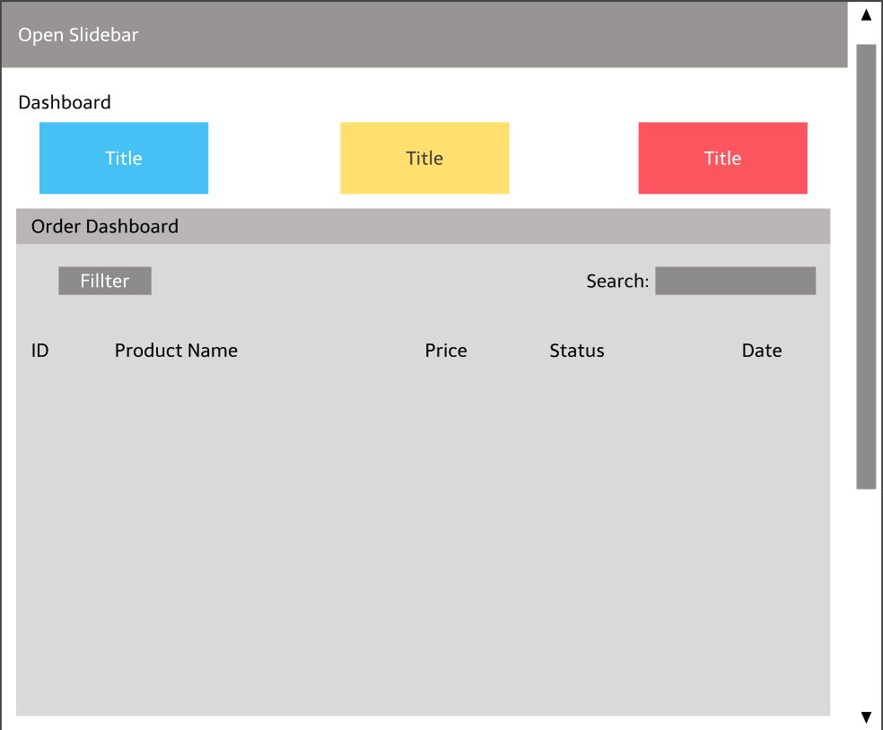

*Figure 2.41.1 Seller Dashboard screen*

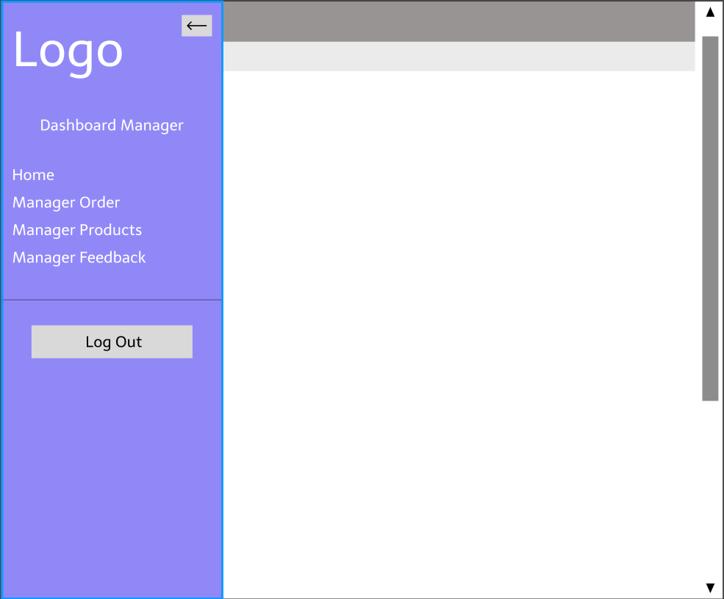

*Figure 2.41.2 Open Slidebar on Seller Dashboard*

* Function Details: Displaying the Main Dashboard panel, Seller clicks the Open Sidebar button to open tasks such as Manage Orders, Manage Products, Manage Blogs, View User Feedback or Log Out.
* Use-Case Description:

|  |  |
| --- | --- |
| Use Case ID | UC-40 |
| Use Case Name | Seller Dashboard |
| Actor | Seller |
| Description | Show detailed store statistics (Number of visitors to the store, total products, total orders, list of products ordered) |
| Precondition | None |
| Post-Condition | None |
| Main Flow | 1. Sign in with your Seller account  2. Click the Management link in the navbar  3. End of the Use-Case |
| Alternative flows | None |

### 2.42. Manager Order (Seller)

* Function trigger: When the seller clicks Manage Orders in the Slidebar.
* Function description:
  + Actors/roles: Seller.
  + Purpose: Allows sellers to view order listings, update order status.
  + Data processing: Load data from the database to the website, update the order status and save it in the Order Status table.
* Screen layout:

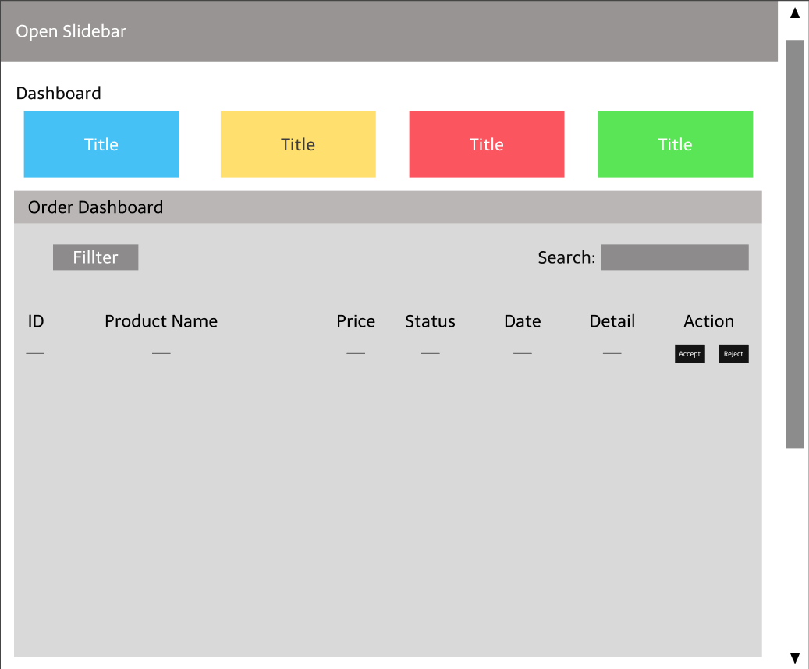

*Figure 2.42 Manage Orders screen*

* Function Details: View store revenue, order list, order status update, search.
* Use-Case Description:

|  |  |
| --- | --- |
| Use Case ID | UC-41 |
| Use Case Name | Manager Orders |
| Actor | Seller |
| Description | Displays a list of the user's orders placed, the status of the order. Allows the seller to update the status of the order, view the details of the products in the order |
| Precondition | None |
| Post-Condition | None |
| Main Flow | 1. Sign in with your Seller account  2. Click the Management Order link in the slidebar  3. Select order status (Waiting for confirmation, packaging, delivery, canceled, completed) to update  4. Click the button Update to update order status  5. Click the View button to view that order details  6. End of the Use-Case |
| Alternative flows | None |

### 2.43. Manager Product (Seller)

* Function trigger: When the seller clicks Manage Product in the Slidebar.
* Function description:
  + Actors/roles: Seller.
  + Purpose: Allows the seller to view the list of products.
  + Data processing: Load data from the database onto the web page to display on the screen.
* Screen layout:

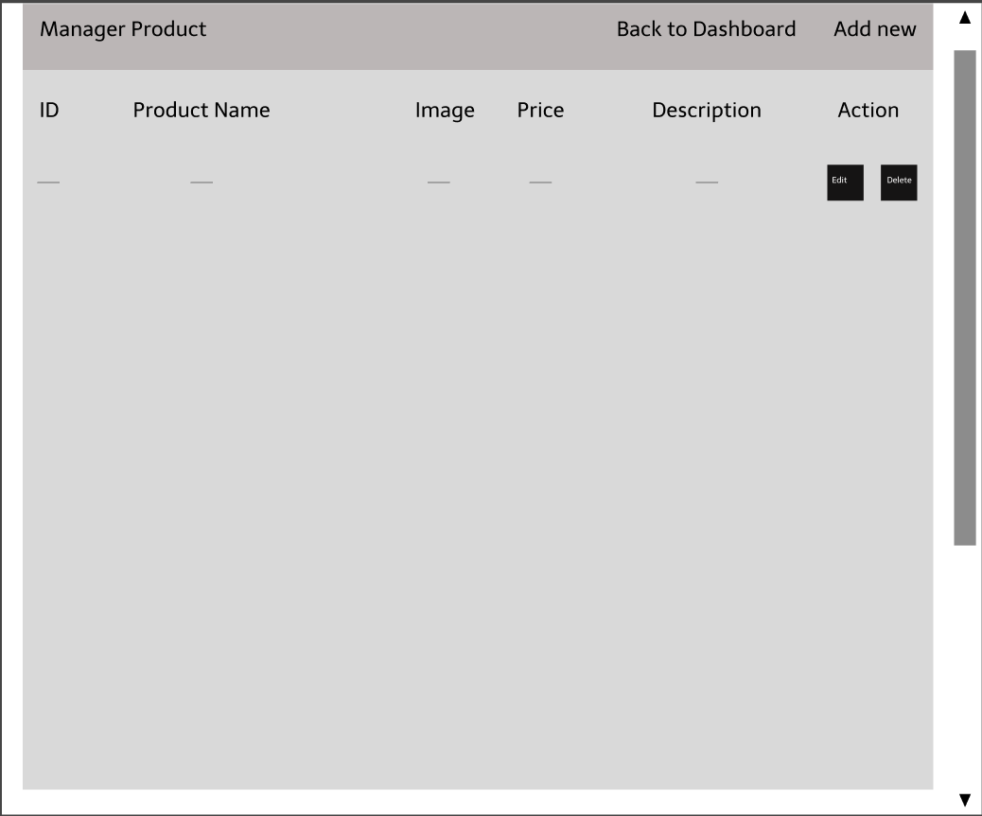

*Figure 2.43 Manager Products screen*

* Function Details: Show a list of products currently in the store.
* Use-Case Description:

|  |  |
| --- | --- |
| Use Case ID | UC-42 |
| Use Case Name | Manager Product |
| Actor | Seller |
| Description | Page used to manage the products of the seller's store |
| Precondition | None |
| Post-Condition | None |
| Main Flow | 1. Sign in with your Seller account  2. Click the Management Product link in the slidebar  3. End of the Use-Case |
| Alternative flows | None |

### 2.44. Add new Product (Seller)

* Function trigger: When the seller clicks the Add New button on the top right side of the screen.
* Function description:
  + Actors/roles: Seller.
  + Purpose: Allow sellers to post new products.
  + Data processing: Insert data into the Products table in the database.
* Screen layout:

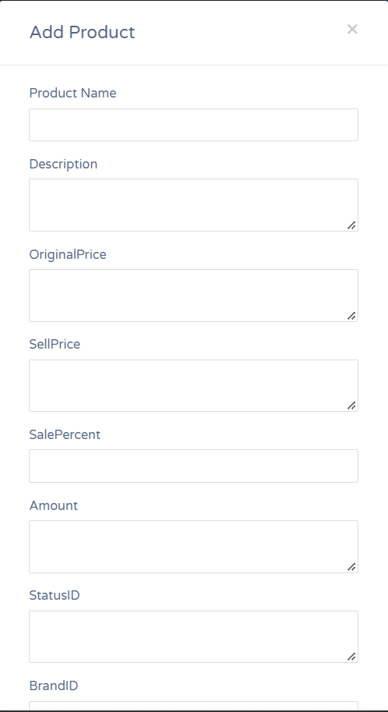

*Figure 2.44 Add new Product screen*

* Function Details: Add a new product to the list of existing products.
* Use-Case Description:

|  |  |
| --- | --- |
| Use Case ID | UC-43 |
| Use Case Name | Add new Product |
| Actor | Seller |
| Description | Allow seller to add new products to their store |
| Precondition | None |
| Post-Condition | None |
| Main Flow | 1. Click the "Add New Product" button  2. Enter product information in the boxes: product name, description, original price, discount price, quantity, product category, photo  3. Click the "Add product now" button to insert into the database  4. End of the Use-Case |
| Alternative flows | None |

### 2.45. Edit Product

* Function trigger: When the seller clicks the Update button.
* Function description:
  + Actors/roles: Seller.
  + Purpose: Allows sellers to edit product information.
  + Data processing: Execute the Update statement in the database to update the data in the Products table.
* Screen layout:

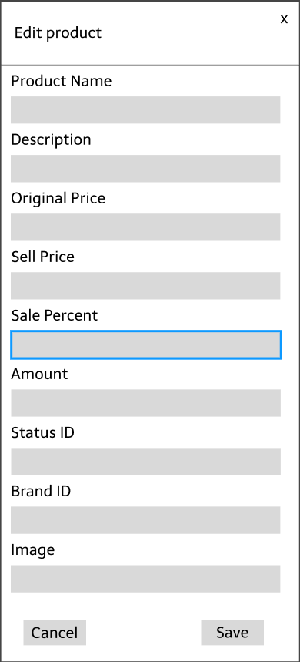

*Figure 2.45 Update Product screen*

* Function Details: Update product information.
* Use-Case Description:

|  |  |
| --- | --- |
| Use Case ID | UC-44 |
| Use Case Name | Update Product |
| Actor | Seller |
| Description | Allow seller to update product information |
| Precondition | None |
| Post-Condition | None |
| Main Flow | 1. Click the "Update" button  2. Product ID field will not be updated, enter new product name, description, new price, new discount, quantity and new image  3. Click the "Update product" button  4. End of the Use-Case |
| Alternative flows | None |

### 2.46. Delete product

* Function trigger: When the seller clicks the Delete button.
* Function description:
  + Actors/roles: Seller.
  + Purpose: Allow users to remove products from the list.
  + Data processing: The system sends a message asking to confirm Delete the product.
* Screen layout:



*Figure 2.46 Delete Product*

* Function Details: Delete product
* Use-Case Description:

|  |  |
| --- | --- |
| Use Case ID | UC-45 |
| Use Case Name | Delete Product |
| Actor | Seller |
| Description | Allow seller to delete product |
| Precondition | None |
| Post-Condition | None |
| Main Flow | 1. Show List products  2. Click the "Delete" button  3. The system displays the message "Are you sure you want to delete this product?"  4. End of the Use-Case |
| Alternative flows | 2a. Click the "No" button  1. Back to Manage Product page  2. Return to Main Flow step 1  2b. Click the “Yes” button  1. The system will delete product data  2. Return to Main Flow step 1 |

### 2.47. Feedback List (Seller)

* Function trigger: When the seller clicks Manage Feedback in the Slidebar.
* Function description:
  + Actors/roles: Seller.
  + Purpose: Show seller all star reviews and user feedback on the product.
* Screen layout:

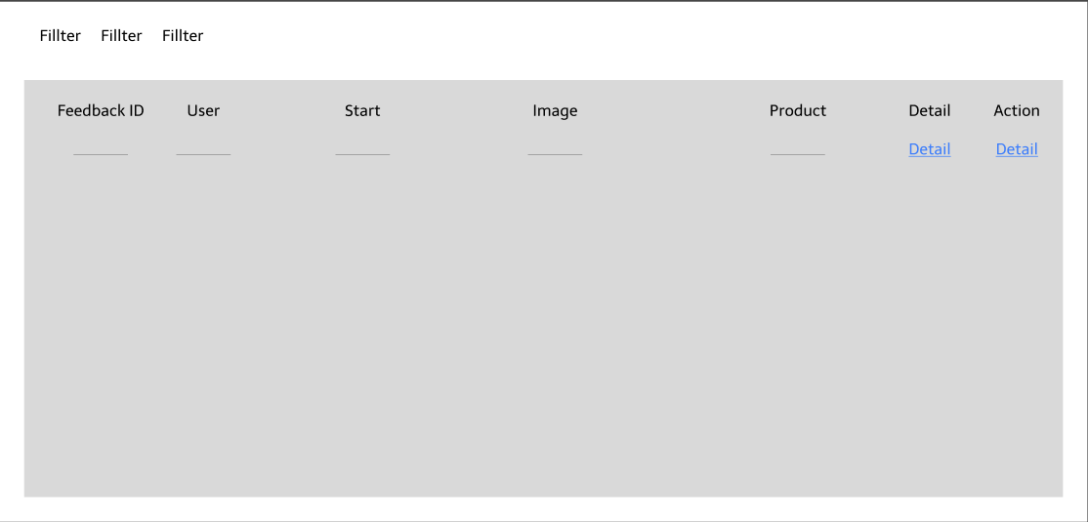

*Figure 2.47 List Feedback screen*

* Function Details: Displays all user feedback reviews about the product, can be sorted by Star rating, by time, alphabetically by username, ..
* Use-Case Description:

|  |  |
| --- | --- |
| Use Case ID | UC-46 |
| Use Case Name | List Feedback |
| Actor | Seller |
| Description | Show list of Feedback |
| Precondition | None |
| Post-Condition | None |
| Main Flow | 1. Click on Manager Feedback on the sidebar  2. End of the Use-Case |
| Alternative flows | None |

### 2.48. Reply Feedback

* Function trigger: When the user clicks the Reply button in the Actions section, the system directs the user to the Feedback reply page.
* Function description:
  + Actors/roles: Seller.
  + Purpose: Let merchants see and respond to user feedback.
  + Data processing: The system records the seller’s answer and updates the data and then returns the message to the user.
* Screen layout:

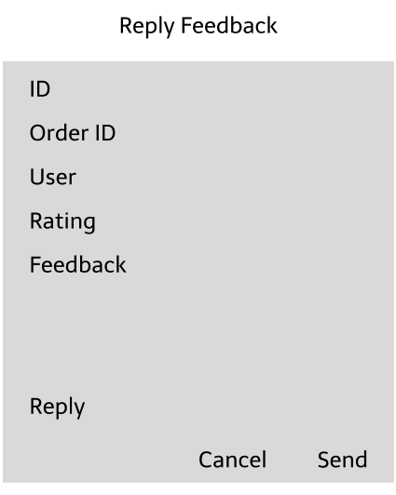

*Figure 2.48 Feedbakc Detail screen*

* Function Details: Send a reply message or update a reply message.
* Use-Case Description:

|  |  |
| --- | --- |
| Use Case ID | UC-47 |
| Use Case Name | Reply feedback |
| Actor | Seller |
| Description | Allow sellerto reply to feedback of user |
| Precondition | None |
| Post-Condition | None |
| Main Flow | 1. Click “Reply feedback” button  2. Enter your reply  3. Click “Submit” button  4. End of the Use-Case |
| Alternative flows | None |